Guidance for DoF Revit Template

The Department of Finance has prepared a Revit Template to facilitate the following RP02C purposes:
- Worksheets: As part of RP602C process, DoF Customers must provide information about Condo/ Child Lots. Parameters within the template will help to pull data from models and create schedules that can be transferred to the Worksheet form.
- Drawings: As part of RP602C process, DoF Customers must provide drawings especially formatted for DoF Tax Map Unit purposes. Titleblock, guidelines and parameters will allow DoF customers to prepare these drawings expeditiously.
- Revit File Upload: The file uploaded by customers will essentially just be the “Area” geometries and their relevant condo worksheet data – particular importance is on the tax lot or BBL identity data. It may look like an empty Revit file with no geometry, but the area footprints will be translated into 3D tax lot visuals in DoF’s future 3D Tax Lot software platform.

If your file meets the following criteria, follow the corresponding steps:
Scenario 1 | You do not yet have a Revit file but are looking to start | Follow all instructions in this document. Any variances will be called out for this scenario.
Scenario 2 | You have a Revit file with areas but no worksheets or DoF RP602C Drawings | Follow all instructions in this document.
Scenario 3 | You already have a Revit file, worksheets and RP602C Drawings. You are looking to upload your Revit file. | Skip to “Revit File Upload” section.

The examples in this document are for scenario 2, that you already have an existing Condo Project file generated natively in Revit that contains “condominium areas” for every unit in the building – i.e. the area schema that is used to calculate Condominium Area square footage for the DoF worksheet upload.

Download the Template
D0) Go to DoF Website and Download the Revit template that corresponds with your version of Revit and the shared parameters file.
D1) Load Shared Parameters into your project – this may be expedited by using a third-party parameter manager Revit plugin such as the one created by DiRoots. Or, in the same instance of Revit, simply copy the existing area in the downloaded Revit template into a new area plan view of your file (Refer to D2.a).
D2.a) Set up your Revit File to receive the new Area Schema. Go to the Architecture tab and click on the “Room & Area” drop down to select “Area and Volume Computations.”
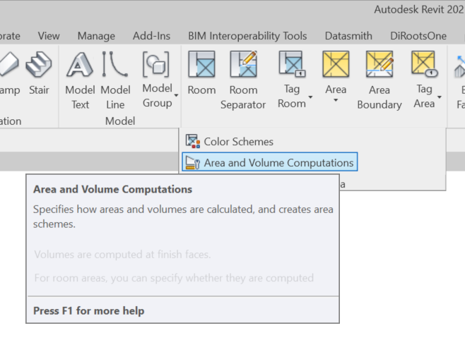
In this pop up window, select the ‘Area Schemas’ tab and create a new schema called “DoF Condos.” (The description of the schema is not as important – you can just use the default.) 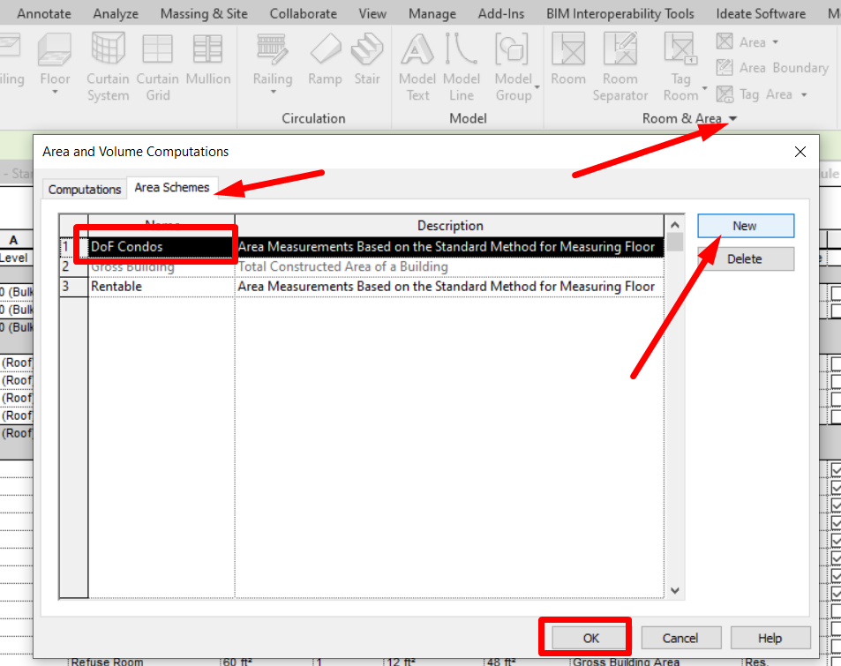

D2.b) Copy the sample Area from the Template File. Make sure the downloaded Revit Template and your project file are side by side in the same instance of Revit. In the template under the Area Plans view called Import Level:
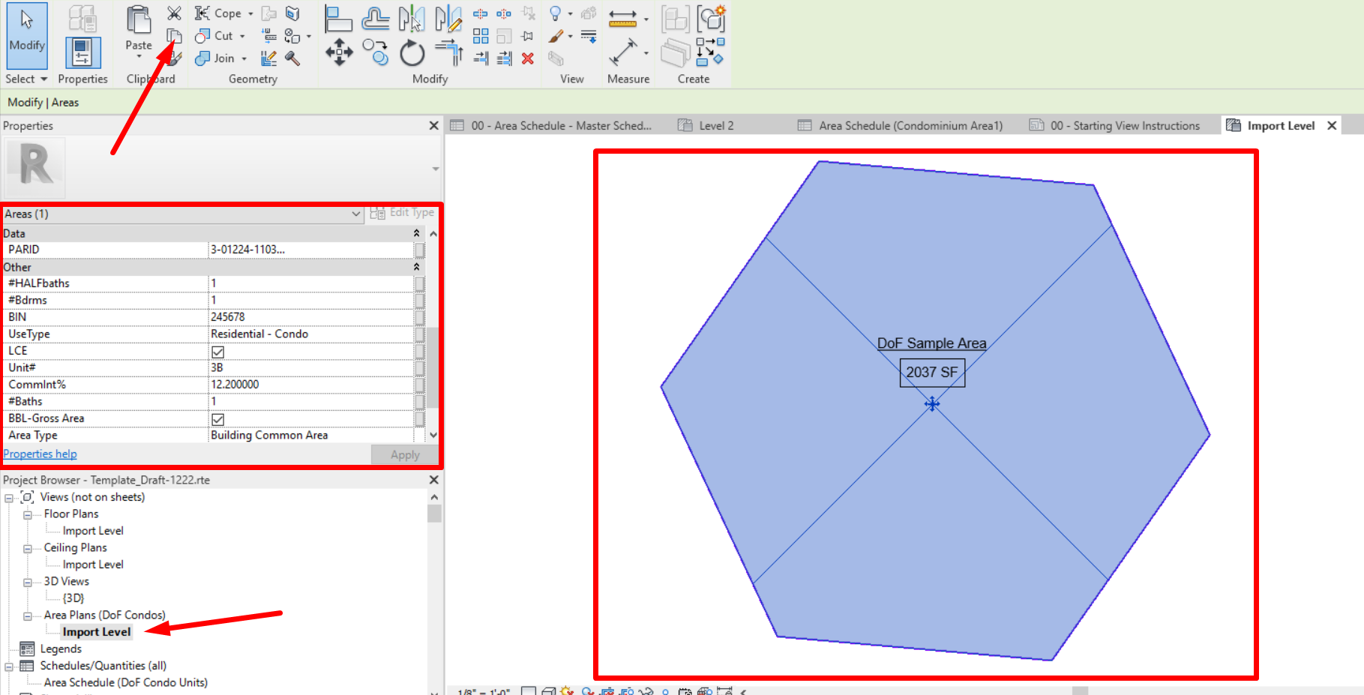

Note: When copying the DoF Sample Area, it is not important to include the Area Tag and boundaries and these can be filtered out.
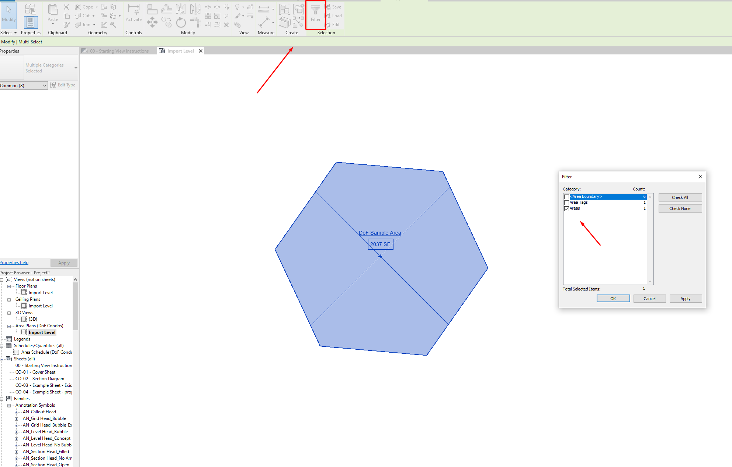

D2.c) In your file create a new Area Schema and Area Plan. Again, make sure your project is in the same Revit instance as the DoF Template file. On the Architecture Tab, select the Area Drop down and create a new Area Plan of the type/schema you just created -- ‘DoF Condos’.
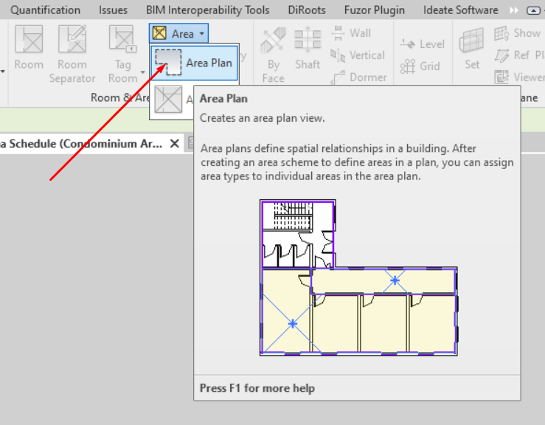

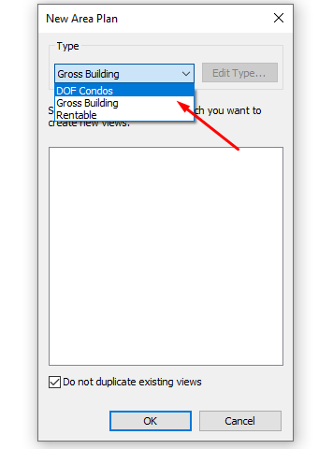
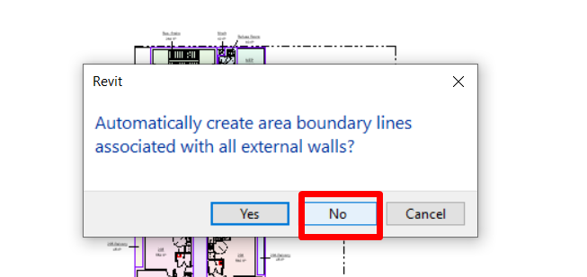

D2.d) Paste the Template sample Area in to your DoF Condos Area Plan:
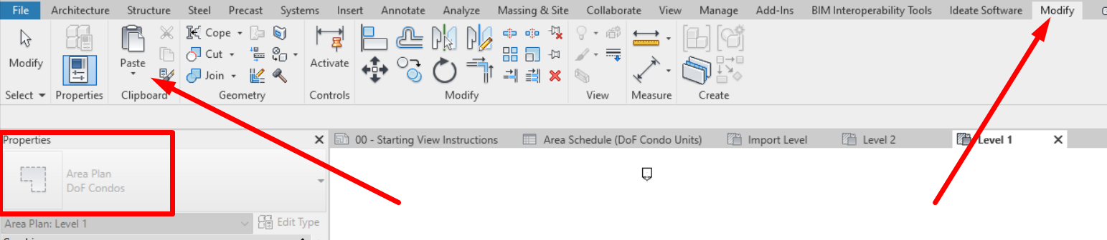

You will likely get an error that looks like this, but you can ignore it and see that the Area parameters from the template file have been included into your project’s project parameters:
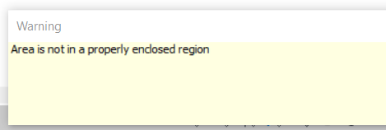

You can check that the parameters have been added by looking at your project parameters or by seeing the field options in an Area Schedule. You should see the following added parameters: PARID; UNIT#; CommInt%; Use Type; #Bdrms; #Baths; #HALFBaths; LCE

D3) Be sure to delete the ‘DoF Sample Area’ geometry after you have pasted it into your project. You can also delete the “Dof Condos” scheme if you already have your condo lots drawn in another Area Scheme.
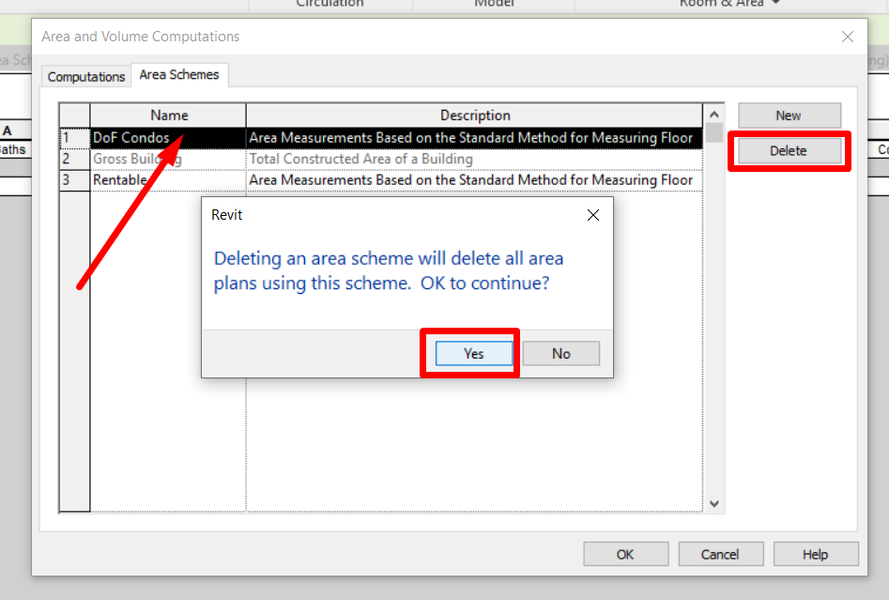

Worksheet :
W1)
Scenario 1: If you do not yet have the Condominium Lots defined as Areas in your Revit project, you may use the “DoF Condos” Area schema and create an “Area” per condominium lot.
Limits of condo unit areas bound by:
- Outermost face of exterior walls
- Outermost face of walls with residential common element or limited common element
- Mid-wall of party walls between contiguous Tax Lots

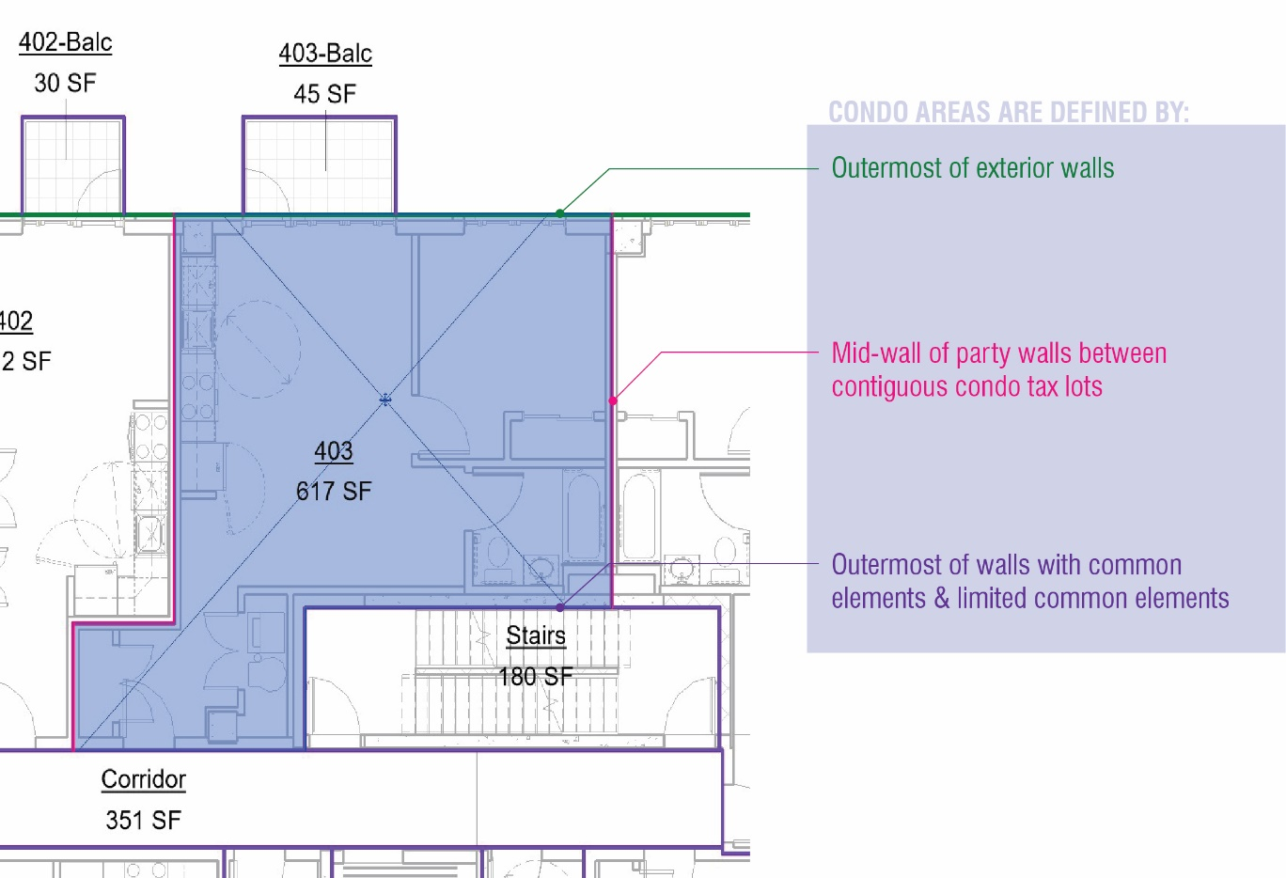

Scenario 2: Assuming you already have condominium lots as “Area” category geometry drawn in your project, create a new schedule for your Condominium Area schema and format the fields to be as follows, to mimic the RO602C worksheet downloaded from the application site:
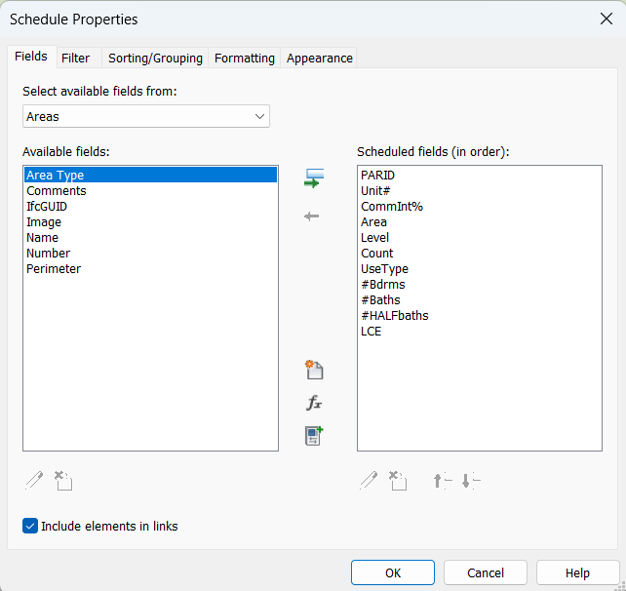
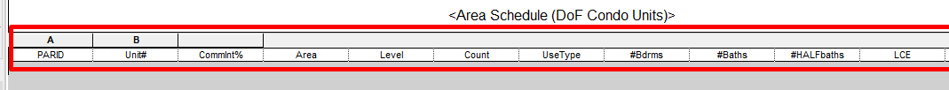

W2) In the resulting schedule, populate the parameters per unit area.
- PARID = BBL of Condo Unit
- UNIT# = Unit number of Condo
- CommInt% = Common Interest Percentage
- Use Type = I.e: Hotel, industrial, Misc. Commercial, Office, Residential – Condo, etc.
- #Bdrms = Number of bedrooms
- #Baths = Number of bathrooms
- #HALFbaths = Number of half bathrooms (toilet and sink but no shower/tub)
- LCE = A checkbox yes/no parameter. If a Limited Common Element (LCE) is associated with the unit, check the box.
The following parameters in the worksheet are represented by the following default Revit parameters:
- UnitSqFt = Area
- Level = Floor
- TotalUnits = Count

W3) Be sure that all areas that are to be included in Worksheet contain the unit BBLs in the “PARID” instance parameter for the area. Note you can filter to show the schedule to just show these areas.
W4) If your project contains representative/ typical floors on sheets, it is important that the areas on the typical floor are grouped, copied to each relevant level then ungrouped, so there is a unique area for every unit. Each area will have instance data relevant for the Worksheet upload.
W5) Format Area so it rounds to the nearest square foot and remove “Square Foot” units.
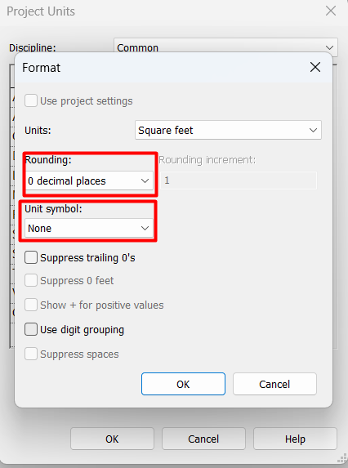
W6) Export schedule as txt.
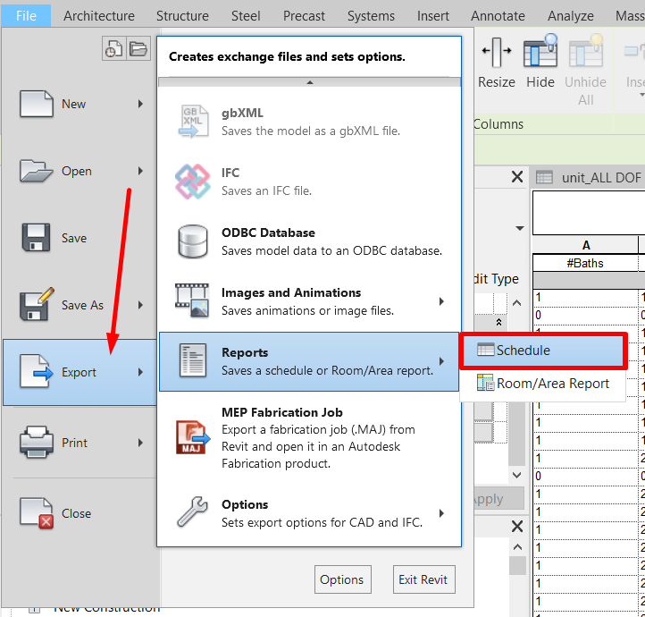
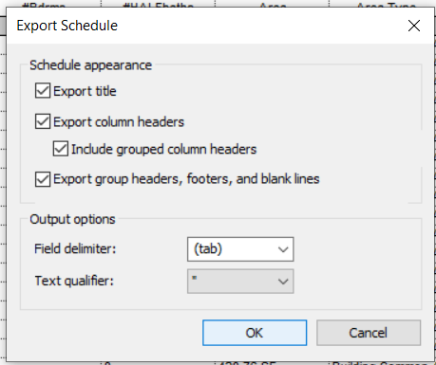

W7) Open in Excel as a tab delimited file.
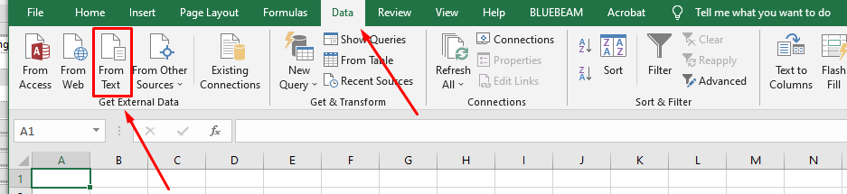

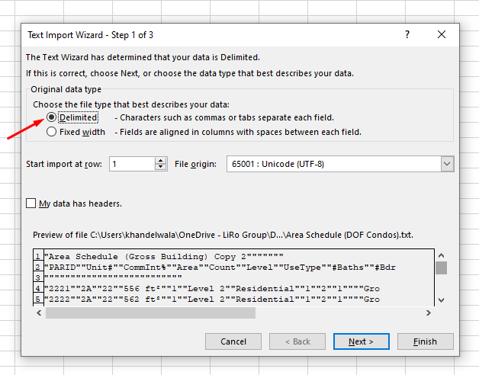
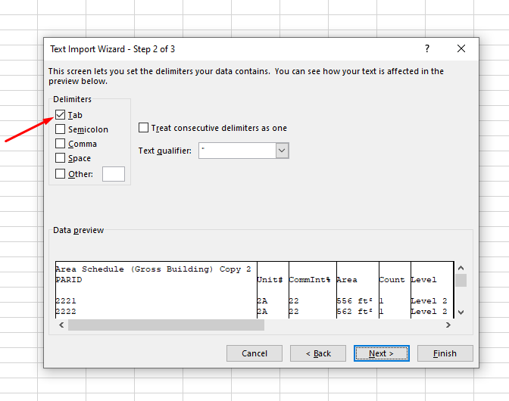
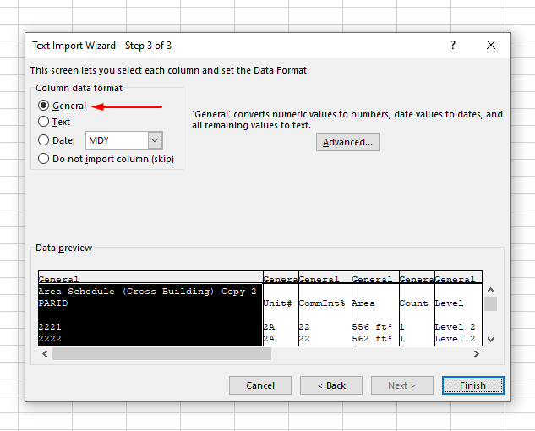
W8) Transfer data to worksheet Excel template downloaded from DoF RP602-C Application.
W9) Upload worksheet Excel to DoF RP602-C Application with other documents.
W10) Refer to “Worksheet” Checklist at end of this document

Sheets
There are sample sheets in the template. These include instructions, parameters and placeholder text that may be useful for your project submission to DoF. It is best if you copy these sheets/ title block into your file. Please note, the Tax Map Unit uses a standard 11” x 17” paper size for prints, so the title block is set to print at 50% on to 11” x 17” pages.
S1) Create sheets in your Main File Model. Open Sheet views in the same instance of Revit and copy over the sheets content to your working Revit File sheets.
S2) Please indicate on your sheets the name of your Condo Tax Lot Number (BBL) parameter. In the DoF template, that parameter is called “PARID.” In DoF sheet examples, you will see where and how to indicate the name of this parameter. This will help our tax unit to efficiently filter your condo data.
S3) Refer to “Drawing Sheets” Checklist at end of this document

Revit File Upload:
The file being uploaded to DoF does not contain any visible geometry. The Revit file will only contain the areas representing condominium units, and their associated data parameters that align with what is populated in the worksheet. The area geometry and data will ultimately be pushed into the Department of Finance digital mapping software to visualize the location of the condominium units in the city.
Before uploading, it is important to duplicate and detach your working project file as the submitted Revit file will not include your geometry – it will only contain Area information. The submitted Revit file must be less than 4GB.
U1) Make a detached duplicate of your condo project Revit file. Save a detached file, or when opening it, detach from central and save as a new file as below.
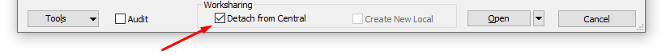
U2) Delete geometry: In a 3D view where everything is visible (all model categories, worksets and phases), select everything using the filter, and delete all geometry except levels. Make sure geometry that is pinned is unpinned.
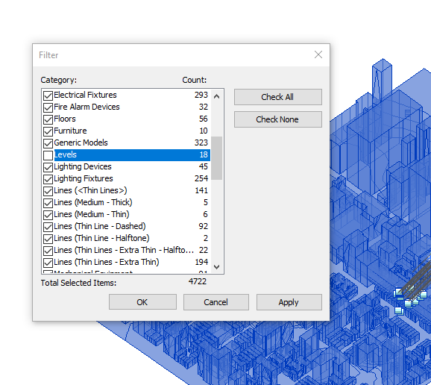

U3) Purge Unused. Go to “Manage” tab and “Purge Unused.” Check All and click OK.
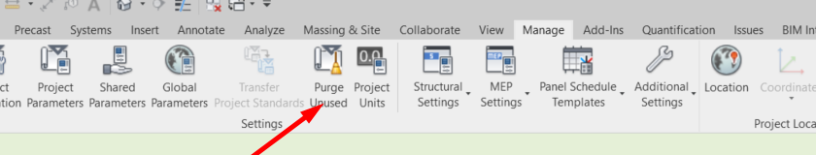

U4) Delete extra family Area schemas from your project. Go to the ‘Room & Area’ drop down and select ‘Area and Volume Computations.’ Delete all Area Schemas that are not relevant to the DoF condominiums.
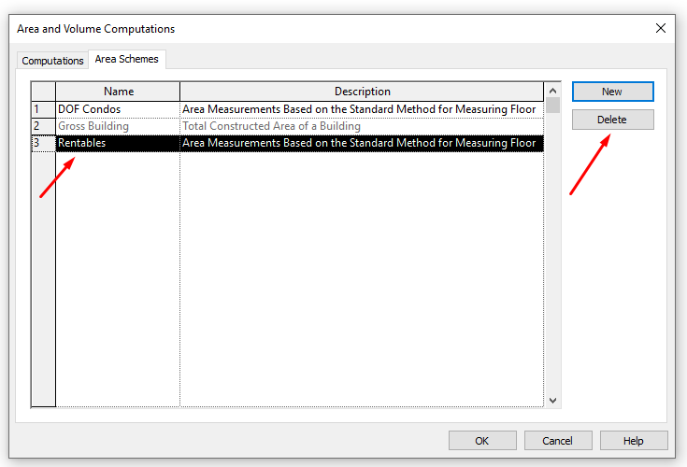
What you will have left is a Revit file that looks as though it doesn’t have any geometry, and only one or two Area schemas that represent your Condominium Units. Please check that the condo areas are still in your file by looking at a relevant schedule. All units that are relevant to the DoF Worksheet should have the BBL (condo lot number) values populated into the “PARID” Area parameter. If you have your condo lot numbers populated in a parameter named differently than “PARID”, please indicate this in notes on your Section Diagram sheet.
U5) Refer to “Delivery of Revit Model” Checklist at end of this document

Checklists for DoF RP602C Submission

Worksheet (DoF Area Schedule)
□ Project information is populated within this file [Click Manage Tab, Project Information] and consistent with other documentation.
□ Development information: common area square footage (SF) appears to be approximately correct based on floor plans (rounded to the nearest square foot is allowed.)
Building Information:
□ Must be a unique building number and building name for each building
□ Number of stories matches floor plans, declaration, etc.
□ Address is accurate and formatted correctly

Child lot information:
□ Unit No, BBL (PARID attribute), Common Interest Percent (CIP), and until SF match schedule B
of the Declaration and floor plans
□ Floor is correct for each unit (units on multiple floors list all floors)
□ Total units field reflects the total number of apartments/ hotel rooms for RES-RENTAL, RES-
COOP, and HOTEL type units
□ Use type is correct for all units and reflects accurate use [Refer to Use Type Legend]
□ Address listed for each unit conforms to other documentation

Drawing Sheets
□ Condo #, Condo name, Address, FKA and NKA lots, and legal language on cover sheet is correct and matches formatting requirements
□ The diagram of the building on page 2 shows a label for each floor, the elevation or floor height for each floor in the building, and indicates grade level
□ The plot plan or site plan shows the layout of the land and meets the same requirements as the RP602C diagram
□ The Condominium Plan Certification language matches DoF requirements, and lists correct information regarding the floors, condo name, condo address, and Borough
□ A date and signature line has been provided for the cartographer and it correctly references the DoF Tax Map Unit title (not “Real Property Assessment Bureau”, “Surveyors Office”, or similar archaic titles)
Certification bar on floor plan pages after page 2:
□ Dimension of units statement is written and matches what is listed in the declaration verbatim
□ Declarant information including name and address are listed
□ Architect/Engineer’s certification statement matches verbatim our requirements and states either “AS BUILT” or “TO BE BUILT”. The As-Built Status agrees with the RP602C

□ The architect/engineer has signed and sealed the plans, with a notary/commissioner of deeds certification as well. All seals and signatures are originals. The State listed in the notary/architect certification is the same state the notary is admitted in (ex. NY State notary may only practice in NY)
□ The architect is the same on the floor plans and the initial application RP602C
□ Tax lot certification statement matches DoF requirements and lists the correct Borough
□ Date and signature line are provided for cartographer
□ The patterns used in the floor plans’ legend to define unit space, LCE, GCE, or other categorizations are used consistently and correctly throughout the floor plans
□ Unit #, Lot #, Unit SF and LCE SF for each unit are labeled on both the floor plans and schedule B to the declaration and match
□ The SF figures assigned to each unit conform generally to the shapes and size of each respective unit, as visually confirmed by the cartographer
□ The general layout of the building as shown on the floor plans contains no obvious errors such as staircases which do not continue from floor to floor, the same roof space is repeated on multiple floors, floor plan is mirrored compared with a photo of the property, or other defects that can be visually confirmed by a cartographer using the floor plans and other resources available such as Cyclomedia, Pictometry, Google Maps, or online marketing materials
□ The floor plans show all floors of the building including roofs, bulkhead roofs, etc. If the architect uses a single page to show a range of floors, the floors in the entire range are identical in layout, area SF, and all other aspects
□ The Section Diagram sheet notes the data scheme and parameter than contains Condominium lot information. Specifically, the name of the parameter with the condo lot number or BBL.

Revit Geometry & Attribute Instructions
□ Populate each of the attributes for Project Information and each of the areas Shared parameters are already in template. Namely:
□ Project Information Parameters: # of Parent Lots, # of Requested Lots, Condo Name, Condo Number, FKA Lot
□ Area Parameters:
PARID = BBL of Condo Unit
UNIT# = Unit number of Condo
CommInt% = Common Interest Percentage
Use Type = I.e: Hotel, industrial, Misc. Commercial, Office, Residential – Condo, etc.
#Bdrms = Number of bedrooms
#Baths = Number of bathrooms
#HALFBaths = Number of half bathrooms (toilet and sink but no shower/tub)
LCE = A yes/no parameter for if the unit contains a Limited Common Element (balcony, storage, terrace, pool, roof deck.)

Note: The following attributes in the worksheet are represented by default Revit parameters and are auto populated:
UnitSqFt = Area
Level = Floor
TotalUnits = Count

□ The condo Area schedule and file should show all levels of the building and each Condo unit identified, even if submitted drawings represent a "typical" floorplan for a range of floors
□ Area boundaries are closed
□ Limits of condo unit areas bound by:
- Outermost face of exterior walls
- Outermost face of walls with residential common element or limited common element
- Mid-wall of party walls between contiguous Tax Lots

Delivery of Revit Model
□ Model is purged and all geometry deleted except the 'Levels' and 'Areas' categories
□ Model contains only one or two Area Types that represent your condominium units with populated worksheet attributes (delete other Area Types from Architecture Tab ==> "Room & Area" drop down ==> "Area and Volume Calculations" ==> "Area Schemes" Tab)
□ Model should be less than 50MB
□ Area data in model should match submitted RP602C Worksheet

