Post-Construction Operation and Maintenance Manual
General Requirements

The New York City Department of Environmental Protection’s (NYCDEP) Stormwater Construction Permit application requires applicants to submit a Post Construction Operation and Maintenance (O&M) Manual in cases when stormwater management practices (SMPs) are required. This O&M Manual is then finalized and submitted with the Stormwater Maintenance Permit request when construction is complete, and the site is stable. Note that one O&M Manual is required for each block and lot where SMPs are used.
This document is meant to be a guide to help professionals with the development of an O&M Manual that is compliant with the requirements outlined in the following documents:
- New York State Permit Discharge Elimination System General Permit for Stormwater Discharges (hereby referred to as the Construction General Permit (CGP))
- Rules of the City of New York.
Applicants are highly encouraged to read the above documents in their entirety prior to beginning the preparation of the O&M Manual to ensure a working knowledge of the underlying requirements.
While DEP has made every effort to ensure the accuracy of all instructions contained in this O&M Manual Template, it is the Rules of the City of New York, not the template, that govern the applicant’s obligations with respect to O&M requirements. In the event of a conflict between the O&M Manual Template and any corresponding provision of the Rules, the applicant must abide by the requirements in the Rules. DEP welcomes questions on the applicability of the Rules of the City of New York, and comments on the O&M Manual Template at any time and will consider those comments in future revisions of this document.
You may contact DEP for O&M Manual related inquiries at:
SWPConstInsp@dep.nyc.gov
Stormwater Permitting Group
NYC Dept. of Environmental Protection
Bureau of Environmental Planning and Analysis
59-17 Junction Blvd, 9th Floor, Flushing, NY 11373

Post-Construction Operation and Maintenance Manual
Template Instructions and Formatting

This O&M Manual template contains helpful instructions and examples for completing each section of the manual. The following formatting rules are used in this O&M Manual template:
- All instructions and prompts are provided in instruction boxes.
while .
Grey boxes must be retained

Blue boxes may be removed

- Textboxes: Replace blue text in text boxes with project specific information
- Image: Replace image placeholders  with project relevant images.
- Narratives: Instruction and examples will help to identify where narratives are required.
Please note that this O&M Manual template is not intended to be exhaustive, and additional information may need to be provided to document any relevant O&M procedures.

Title Page Instructions:
Replace the blue text with the required information if applicable.

Remove instructions before submitting

Post Construction Operation and Maintenance (O&M) Manual

Insert Project/Site Location/Name
Insert Project Site Address, City, State, Zip Code
Insert Project/Site Phone Number

Prepared for:
Insert Owner Company or Organization Name
Insert Contact Name
Insert Address, City, State, Zip Code
Insert Phone Number
Insert Fax/Email

Prepared By:
Insert Company or Organization Name
Insert Contact Name
Insert Address, City, State, Zip Code
Insert Phone Number
Insert Fax/Email

Maintenance Entity:
Insert Company or Organization Name
Insert Contact Name
Insert Address, City, State, Zip Code
Insert Phone Number
Insert Fax/Email

On-site Manual Location
(Right-of-Way and Parks SMPs Only)
Insert Company or Organization Name
Insert Contact Name
Insert Address, City, State, Zip Code
Insert Phone Number
Insert Fax/Email

Inspector:
Insert Owner Company or Organization Name
Insert Contact Name
Insert Address, City, State, Zip Code
Insert Phone Number
Insert Fax/Email

O&M Preparation Date:
Insert Date
BBL:
Insert BBL

Table of Contents
SECTION 1: INTRODUCTION 5
1.1 Overview 6
SECTION 2: SMP INFORMATION 8
2.1 List of SMPs 9
2.2 List of Connected Drainage Structures 10
2.3 SMP Descriptions & Maintenance Recommendations 11
SECTION 3 – SMP INSPECTION AND MAINTENANCE FORMS 21
3.1 SMP Inspection Checklists 22
3.2 SMP Maintenance Checklist 24
3.3 SMP Inspection and Maintenance Tracker Form 26
3.4 Maintenance Permit 28
SECTION 4 – BMP INFORMATION [MS4 Areas and NNI Requirements Only] 29
4.1 List of BMPs [MS4 Areas and NNI Requirements Only] 30
4.2 BMP Descriptions & Maintenance Recommendations [MS4 Areas and NNI Requirements Only] 31
SECTION 5 – BMP INSPECTION AND MAINTENANCE FORMS [MS4 Areas and NNI Requirements Only] 38
5.1 BMP Inspection Checklist [MS4 Areas and NNI Requirements Only] 39
5.2 BMP Maintenance Checklist [MS4 Areas and NNI Requirements Only] 41
5.3 BMP Inspection and Maintenance Tracker Form [MS4 Areas and NNI Requirements Only] 43
SECTION 6 – MARKED UP AS-BUILTS 45
6.1 SMP Location Map 47
6.2 As-Built Plans 48
6.3 Planting/Landscaping Plans 49

SECTION 1: INTRODUCTION

1.1 Overview
Instructions:
The narrative below may be used as an overview for the O&M Manual to describe the purpose and contents.

This section should also remind the inspector that certain reoccurring maintenance issues may indicate that SMPs are not functioning as intended and may require remediation and repair, rather than maintenance. Refer to Level 2 NYS DEC Maintenance Guidance for Stormwater Management Practices and Chapter 5 in the NYC Stormwater Manual for examples of cases where repairs might be needed. Note that any remediation or repair that results in a modification to the SMP requires review and approval of the department. DEP will not perform any Level 2 or 3 investigative inspections.

The narrative should include requirements for Annual Certification of the permit and Maintenance Permit Renewal.

The example narrative below provides guidance on how to report observations that indicate underlying issues. The narrative should be expanded upon and provide site-specific information.
Remove instructions before submitting
The purpose of this manual is to provide instructions, checklists, as-built drawings, and reference documents for the inspection and maintenance of stormwater management practices (SMPs), connected drainage structures (inlets, manholes, outlet control structures etc.), and best management practices (BMPs) at (P.S. XYZ) at 123-45 Example St., City, NY). Regular inspections and maintenance shall be performed to maintain the function of the SMPs and BMPs in accordance with this document.
Inspections shall be completed per this manual or the attached manufacturer manuals and shall be completed by designated individuals at the required intervals for each SMP, connected drainage structure and BMP. Maintenance shall also be performed at the required intervals, or as needed based on inspection data.
The inspection and maintenance records shall also detail follow up action items should any underlying issues be discovered. These inspection checklists are more detailed and specific to different SMPs. Frequent observations of the items below may indicate an underlying issue that may require additional investigation and analysis by a qualified professional. As detailed in Chapter 5 of the NYC Stormwater Manual, examples of some common problems that may need to be addressed via remediation or repair include:
- Erosion Problems
- Poorly Performing Plantings
- Differential Settlement
- Sedimentation and Clogging
- Structural Defects
Inspection and maintenance checklists, or related records, shall be kept on file within the building’s maintenance office, or within the designated location indicated on the O&M Manual’s cover sheet, for review upon request. Such documentation is required for Stormwater Maintenance Permit Annual Certification and Permit Renewal. The table below outlines important details regarding these two submissions.

 | Annual Certification | Permit Renewal
Documentation | Certification signed by the owner that the SMPs & BMP are operating as designed and have been properly inspected and maintained. | Report certified by a qualified professional that all SMPs are operating as designed
Frequency of Submissions | Yearly | Every 5 years from the date of initial issuance
Timeframe | Submission to DEP within 30 days prior to permit anniversary date | Submission to DEP no later than 30 days prior to permit expiration
Submission Via | SWPTS Portal | SWPTS Portal

SECTION 2: SMP INFORMATION

2.1 List of SMPs

Instructions:
This section consists of a table where the applicant must list each SMP that is proposed for the project, along with its associated identification (ID) details. The contents of the table are as follows:
- SMP Type column – List the name of each individual practice in the rows of this column using the SMP naming conventions shown in Chapter 4 of the New York City Stormwater Manual (NYC SWM). There may be more than one practice of the same type.
- DEP SMP ID column – During the application process on the SWPTS Portal, the system will generate a unique ID for each entered practice. The unique ID generated by the SWPTS Portal shall be included in this column. Note that each SMP ID must be separated by contributing drainage areas.
- SMP Structure ID No. column – List the structure number for each SMP. This number should correspond with the number assigned to the SMP in the Utility Plan.
- Function Type column – List the function type (Infiltration, Evapotranspiration, Reuse, Filtration, Detention) of each individual practice in the rows of this column using Figure 4.1 in the New York City Stormwater Manual.
- No Net Increase (NNI) Requirement Column [MS4 Areas Only]– Input the applicable from (Floatables, Phosphorus, Nitrogen, Pathogens) if the SMP is needed to meet NNI requirements as applicable. If the site it not applicable to NNI requirements select N/A for this column. For NNI Best Management Practices (BMPs) for Pathogen Removal see Section 4 of this O&M Manual.
Remove instructions before submitting
SMP Type | DEP SMP ID. | SMP Structure ID No. | Function Type | No Net Increase (NNI) Requirement
Stormwater Gallery | ####
Synthetic Turf Field | ####
Synthetic Turf Field | ####
Example Table:

2.2 List of Connected Drainage Structures

Instructions:
This section consists of a table where the applicant must list each stormwater drainage structure connected to the SMP that is proposed for the project, along with its associated identification (ID) details. Note that drainage structures upstream of the SMP must be listed as maintenance of these structures directly impact SMP functionality. Include any applicable downstream structures in this list that require maintenance, such as an outlet control structure. The contents of the table are as follows:
- Connected Drainage Structure Type column – List the type of drainage structures in the rows of this column. There may be more than one connected drainage structure of the same type.
- Drainage Structure ID No. column – The O&M Manual developer will create unique DS IDs per connected drainage structure or utilize the names provided in the as-built drawings.
Remove instructions before submitting
Example table:
Connected Drainage Structure Type | Drainage Structure ID No.
Inlet | Inlet #1
Inlet | Inlet #2
Manhole | Manhole #1
Manhole | Manhole #2
Outlet Control Structure | OCS #1

2.3 SMP Descriptions & Maintenance Recommendations
Instructions:
This section should contain an overview for each type of SMP or connected drainage structure that requires inspection/maintenance. It should include, at a minimum, the following:
- The type of SMP or connected drainage structure.
- A general description of how the SMP or connected drainage structure functions.
- A general description of the maintenance activities required for the SMP or connected drainage structure and why they are important for the practice’s functionality.
- A detailed list of tools and materials required for SMP access during inspection or maintenance.
- Images, cross-sections, or other diagrams of the SMP or connected drainage structure that reflect the site-specific proposed design of the system.
- A unique color for each SMP or connected drainage structure to be used for cross-referencing throughout the O&M Manual, where indicated.
- A general description of maintenance recommendations followed by a table of maintenance tasks and frequencies. The table is intended to provide maintenance recommendations for the on-site GI systems maintained by property owners. The recommendations include maintenance tasks critical to the first-year post-construction, the warranty period, and on-going maintenance. The purpose of this table is to detail specific maintenance activities and frequencies.
- Manufacturer specific maintenance recommendations and procedures for proprietary systems (e.g., subsurface detention structures) should be supplemented with this guide.
- Specification sheets must be included for SMP products and for soil media/media layers if used by a practice.

Example description sheets shown on the following pages are for illustration purposes only and do not contain all of the required information. Applicants should create their own description sheets that are tailored to the design details of their project.
Remove instructions before submitting

- Color to be used in Sections 3 and 6
Stormwater Gallery
Subsurface gallery consists of underground structures surrounded by stone that are intended to hold stormwater for a pre-determined duration of time before the stormwater infiltrates into the ground or is discharged downstream.
In order to maintain a stormwater gallery system’s functionality, sediment and debris must be regularly removed to prevent clogging of the system and to prevent reduction of the system’s stormwater storage capabilities. Maintenance operators should be careful to extract the sediment/debris and not transfer it downstream into the subsurface storage areas. Sediment removal from stormwater galleries is typically performed using vacuum or flushing systems per the manufacturer’s recommendations.
All maintenance operations must follow OSHA confined space entry requirements.

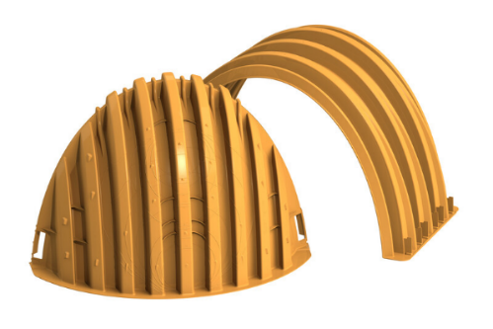
Stormwater Storage Systems:
Figure 1: ADS Stormtech Chambers

ACTIVITY | FREQUENCY
Specify period when maintenance is required (e.g. Warranty Period, Ongoing, etc.)
[Specify inspection and maintenance activities and necessary equipment, be as specific as possible.] | [Specify when inspection or maintenance is required (e.g. Weekly, Biweekly, etc.). Include period over which activities must be completed, along with any specifics concerning when activity intervals should be adjusted.]
[Specify inspection and maintenance activities and necessary equipment, be as specific as possible.] | [Specify when inspection or maintenance is required (e.g. Weekly, Biweekly, etc.). Include period over which activities must be completed, along with any specifics concerning when activity intervals should be adjusted.]
[Specify inspection and maintenance activities and necessary equipment, be as specific as possible.] | [Specify when inspection or maintenance is required (e.g. Weekly, Biweekly, etc.). Include period over which activities must be completed, along with any specifics concerning when activity intervals should be adjusted.]
Table 2.1: [SMP] Inspection & Maintenance

INSERT SPECIFICATIONS IF APPLICABLE

[Insert Specifications If Applicable]

- Color to be used in Sections 3 and 6
Synthetic Turf Field
Synthetic turf material allows runoff to percolate into underlying layers. Common underlying layers include a shock absorbing pad, leveling course, and a stone base. Due to their size, many synthetic turf fields also include internal pipes to help spread water evenly across the entire storage area.
Maintaining the synthetic turf field’s integrity and preventing it from clogging is critical to the systems long-term function and success. Synthetic turf fields should be visually inspected for rips or vegetation to prevent sedimentation from entering the subsurface storage system. Synthetic turf fields should also be cleaned of organic material and debris as needed to prevent clogging.
Note that turf fields cannot be plowed, snow must be allowed to melt on them. If seams are spreading or ripping shortly after installation IMMEDIATELY contact the turf manufacturer.
Avoid using leaf blowers on synthetic turf as this can disturb the infill if your field has rubber or sand infill.

Synthetic Turf Field:
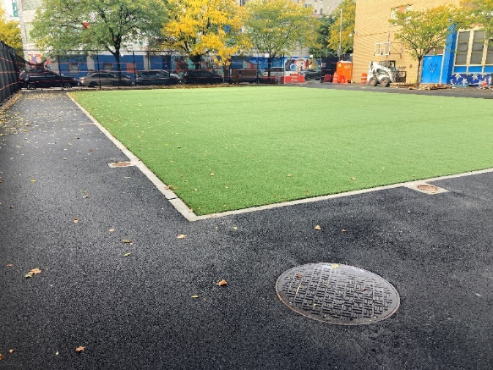
Figure 3: Newly Installed Synthetic Turf Field

ACTIVITY | FREQUENCY
Specify period when maintenance is required (e.g. Warranty Period, Ongoing, etc.)
[Specify inspection and maintenance activities and necessary equipment, be as specific as possible.] | [Specify when inspection or maintenance is required (e.g. Weekly, Biweekly, etc.). Include period over which activities must be completed, along with any specifics concerning when activity intervals should be adjusted.]
[Specify inspection and maintenance activities and necessary equipment, be as specific as possible.] | [Specify when inspection or maintenance is required (e.g. Weekly, Biweekly, etc.). Include period over which activities must be completed, along with any specifics concerning when activity intervals should be adjusted.]
[Specify inspection and maintenance activities and necessary equipment, be as specific as possible.] | [Specify when inspection or maintenance is required (e.g. Weekly, Biweekly, etc.). Include period over which activities must be completed, along with any specifics concerning when activity intervals should be adjusted.]
Table 2.2: [SMP] Inspection & Maintenance

Insert Specifications if Applicable] [
INSERT SPECIFICATIONS IF APPLICABLE

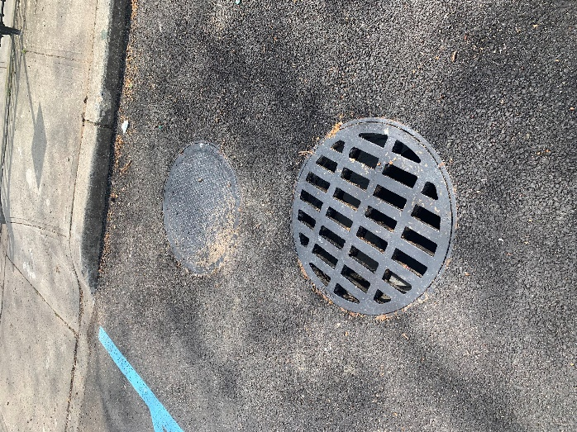
- Color to be used in Sections 3 and 6
Drainage Structures
Drainage structures (including but not limited to inlets, catch basins, manholes, diversion structures, trench drains, beehive grates, underdrains and outlet control structures) are typically used in the following situations:
- Allow stormwater to enter a stormwater drainage system.
- To introduce a change in pipe direction.
- As junctions for multiple pipes.
Drainage structures typically have sumps that accumulate sediment and debris from incoming stormwater and prevent it from entering the pipe. Over time this sediment accumulation may lead to system bypass or backup. In order to prevent this, drainage structures must be periodically inspected and cleaned.
General maintenance procedures are summarized in Section 3. All maintenance operations must follow OSHA confined space entry requirements.

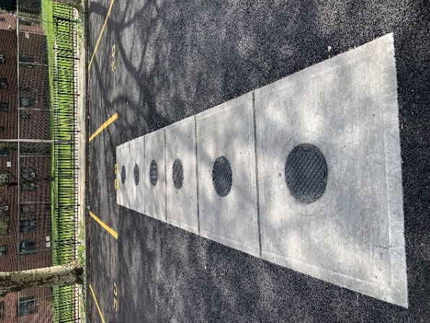
Figure 4: Manhole and Inlet Covers
Figure 5: Subsurface Structure Cleanout Covers
Table 2.3: [Drainage Structure] Inspection & Maintenance

ACTIVITY | FREQUENCY
Specify period when maintenance is required (e.g. Warranty Period, Ongoing, etc.)
[Specify inspection and maintenance activities and necessary equipment, be as specific as possible.] | [Specify when inspection or maintenance is required (e.g. Weekly, Biweekly, etc.). Include period over which activities must be completed, along with any specifics concerning when activity intervals should be adjusted.]
[Specify inspection and maintenance activities and necessary equipment, be as specific as possible.] | [Specify when inspection or maintenance is required (e.g. Weekly, Biweekly, etc.). Include period over which activities must be completed, along with any specifics concerning when activity intervals should be adjusted.]
[Specify inspection and maintenance activities and necessary equipment, be as specific as possible.] | [Specify when inspection or maintenance is required (e.g. Weekly, Biweekly, etc.). Include period over which activities must be completed, along with any specifics concerning when activity intervals should be adjusted.]

[Insert Specifications if Applicable]
INSERT SPECIFICATIONS IF APPLICABLE

SECTION 3 – SMP INSPECTION AND MAINTENANCE FORMS

3.1 SMP Inspection Checklists

Instructions:
One inspection checklist shall be created for each unique type of SMP and unique type of connected drainage structure listed in Section 2.1 and 2.2. Refer to the NYS DEC SMP Inspection Checklist for required inspection items. Note that inspections do not need to be performed by a Qualified Inspector.

The O&M Manual developer shall include the following information, at a minimum, in the inspection checklist:
- Name of the SMP or connected drainage structure and frequency of the inspection item which was set in Section 2.3.
- Color that corresponds with the name of the SMP or connected drainage structure which was set in Section 2.3.
- Spaces where the following information can be written; name and signature of the inspector, contact information, date of inspection, address, weather conditions, location of the practice.
- A list of each component of the system to be inspected, along with inspection activities associated with each component and frequency of inspection item. (Note that these components must be aligned with those included in the Inspection and Maintenance Tracker Form in Section 3.3)
- Spaces where inspectors can mark the completion of each inspection activity and any associated observations.
- Include instructions for what to do with the completed inspection checklist. Instructions should reflect the following requirements: Inspector must fill out one (1) Inspection Checklist form per SMP per inspection visit. The Inspector must update The Inspection and Maintenance Tracker Form in Section 3.3 after each inspection visit. The completed forms should be stored with the O&M Manual.

An example inspection checklist is shown on the following page for illustration purposes only and does not contain all the required information. Applicants should create their own inspection checklists that are tailored to the design details of their project.

Refer to Chapter 12 of the NYS DEC Stormwater Design Manual.

Remove instructions before submitting

Stormwater Gallery Inspection Checklist

Inspected by:  John Doe  X_____________________  Insert Phone Number  Insert Email |  |  |  | Site Address:  123-45 Example St., City, NY
Date of Inspection: 6/18/2023 |  |  |  | Weather: Sunny 85 degrees F
Location Description: Northeast Corner of the School Yard
Frequency | Activity Item # | Inspection Items | Inspected?  (Y/N) | Follow Up Action Needed
Monthly | - Erosion control measures and any flow-spreading devices (Warranty period only)
 | 1a. | Observed signs of soil erosion runoff towards asset inlets? | Y | No Follow Up Action Required
 | 1b. | Has the vegetation taken hold and is healthy? | Y | No Follow Up Action Required
Monthly | - Inspection/Cleanout Ports
 | 2a. | Any debris and accumulated sediment around lids? | Y | No Follow Up Action Required
 | 2b. | Lids/covers damage? | Y | No Follow Up Action Required
 | 2c. | Sediment accumulated in any filters? | Y | Remove and empty filters per Manufacturer’s O&M
 | 2d. | Is water present in subsurface system more than three (3) days after a storm event? | Y | No Follow Up Action Required
 | 2e. | Is the observed sediment accumulation in surrounding chambers at or above 3” (80mm)? | Y | No Follow Up Action Required
 | 2f. | Is the integrity of the Chamber wall compromised (e.g., root penetration)? | Y | No Follow Up Action Required
Annual | - Isolator Rows
 | 3a. | Any debris and accumulated sediment around lids? | N | Not inspected this visit, will be inspected annually in August
 | 3b. | Lids/covers damage? | N | Not inspected this visit, will be inspected annually in August
 | 3c. | What is the depth of sediment in the isolator row? | N | Not inspected this visit, will be inspected annually in August
ONCE INSPECTION IS COMPLETED:
- KEEP COMPLETED INSPECTION CHECKLIST IN O&M MANUAL
- FILL OUT INSPECTION AND MAINTENANCE TRACKER FORM

SMP Maintenance Checklist

Instructions:
One maintenance checklist shall be created for each unique type of SMP and unique type of connected drainage structure listed in Section 2.1 and 2.2.

The O&M Manual developer shall include the following information, at a minimum, in the maintenance checklist:
- Name of the SMP or connected drainage structure and frequency of the maintenance item which was set in Section 2.3.
- Color that corresponds with the name of the SMP or connected drainage structure which was set in Section 2.3.
- Spaces where the following information can be written; name and signature of the maintenance provider, contact information, date of maintenance, address, and weather conditions.
- A list of maintenance activities to be performed, along with the required frequency and photographs of the activity. (Note that these components must be aligned with those included in the Inspection and Maintenance Tracker Form in Section 3.3)
- Include instructions for what to do with the completed maintenance checklist. Instructions should reflect the following requirements: Maintenance personnel must fill out one (1) Maintenance Checklist form per SMP per maintenance visit. The maintenance personnel must update The Inspection and Maintenance Tracker Form in Section 3.3 after each maintenance visit. The completed forms should be stored with the O&M Manual.

An example maintenance checklist is shown on the following page for illustration purposes only and does not contain all the required information. Applicants should create their own maintenance checklists that are tailored to the design details of their project.

Refer to Chapter 12 of the NYS DEC Stormwater Design Manual.

Remove instructions before submitting

Stormwater Gallery Maintenance Checklist
Maintained by:  John Doe  X_____________________  Insert Phone Number  Insert Email |  | Site Address:  123-45 Example St., City, NY
Date of Maintenance: 6/30/2023 |  | Weather: Sunny 85 degrees F
FREQUENCY | MAINTENANCE ACTIVITY DESCRIPTION & NOTES | ACTIVITY PHOTO
Quarterly | Isolator row jetted and vacuumed.  Required tools: JetVac truck, cones, crow bar, etc. | 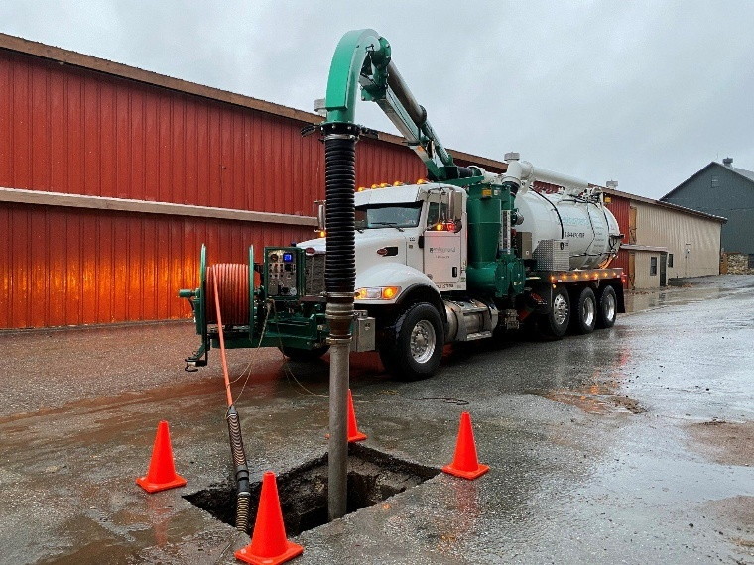
[Maintenance Frequency] | [Maintenance Activity Description] | 
ONCE MAINTENANCE ACTIVITY IS COMPLETED:
1) KEEP COMPLETED MAINTENANCE CHECKLIST IN O&M MANUAL
2) FILL OUT INSPECTION AND MAINTENANCE TRACKER FORM

3.3 SMP Inspection and Maintenance Tracker Form
Instructions:
- The purpose of this form is to track when inspection and maintenance activities for each SMP and connected drainage structure occurred throughout a single year.
- Frequency of activities are established in Section 2.3. These frequencies should be consistent with the frequency table in the inspection and maintenance tracker form.
- A single Inspection and Maintenance Tracker Form shall be used per year and be stored in the O&M Manual.
- The project name, location and year that the SMP Inspection and Maintenance Tracker will be used shall be filled out at the top of the form.
- When activities are completed, they should be recorded in the SMP Inspection and Maintenance Tracker Form.
- The “Action” column shall be filled out according to activity type (Inspection, Maintenance, or Follow Up)
  - Inspection activities (I) include those listed in Section 3.1.
  - Routine maintenance (M) includes scheduled tasks intended to ensure functionality and prevent issues.
  - Follow Up (F) actions include specific tasks performed in response to an identified issue or observation. Follow Up actions are identified during routine maintenance or inspections.
- The “Date” column shall be filled out according to the date when an inspection, maintenance, or follow up activity is completed.
- The “Notes” column shall be used to briefly record any observations made during inspection, maintenance, or follow up activities. This will help track potentially recurring issues. Additional sheets may be added for observations as required. Refer to New York City Stormwater Manual Chapter 5 for suggested maintenance activities and frequencies.
An example SMP Inspection and Maintenance Tracker is shown on the following page for illustration purposes only and does not contain all of the required information. Applicants should create their own form that is tailored to their project.

Remove instructions before submitting

REQUIRED FREQUENCY
Activity Type | Stormwater Gallery | Synthetic Turf Field | Connected Drainage Structure
Inspection | MONTHLY | MONTHLY | BI-MONTHLY
Maintenance | QUARTERLY | QUARTERLY | QUARTERLY
Follow Up | AS INDICATED IN SECTION 3.1
SMP INSPECTION AND MAINTENANCE TRACKER FORM
Year: 2023 Project Name: P.S. XYZ Green Infrastructure
Performed by: Contracted Company or Responsible Party Location: 123-45 Example St., City, NY
INSPECTION AND MAINTENANCE TRACKER: Fill out the table when Inspection or Maintenance is completed.
Stormwater Gallery |  |  | Synthetic Turf Field |  |  | Connected Drainage Structure
Action | Date | Notes | Action | Date | Notes | Action | Date | Notes
M | X/XX/XX
I | X/XX/XX
F | X/XX/XX
Key:
I – Inspection
M – Maintenance
F- Follow Up

3.4 Maintenance Permit
PLACEHOLDER FOR STORMWATER MAINTENANCE PERMIT.
INSERT WHEN RECEIVED.

Example

SECTION 4 – BMP INFORMATION [MS4 Areas and NNI Requirements Only]

4.1 List of BMPs [MS4 Areas and NNI Requirements Only]

Instructions:
This section consists of a table where the applicant must list each BMP required to mitigate potential sources of pathogens present at developed sites within MS4 areas.
      - BMP Number – Create a unique number per BMP type and insert in this column.
- BMP Type column – Develop a list of BMPs to be implemented to mitigate pathogens and insert them in this column. See table 2.6 of the NYC SWM for examples of BMPs per land use. Note that this list is not exhaustive or prescriptive and the O&M manual developer may propose additional site-specific measures.
- Source of Pathogen – Indicate the source of pathogen that each BMP will mitigate in this column.
Remove instructions before submitting
Example table:
BMP Number | BMP Type | Source of Pathogen
1 | Latched or Heavy-Lidded Trash Containers | Floatables
2 | Waste Disposal for Pets | Pathogens, Phosphorus, Nitrogen
3 | Monitor for Illegal Dumping into Catch Basins | Floatables

BMP Descriptions & Maintenance Recommendations [MS4 Areas and NNI Requirements Only]

Instructions:
This section should contain an overview for each type of BMP that requires inspection/maintenance. It should include, at a minimum, the following:
- The type of BMP.
- A general description of how the BMP functions.
- A general description of the maintenance activities required for the BMP and why they are important for the practice’s functionality.
- Images, cross-sections, or other diagrams of the BMP that reflect the site specific BMPs.
- A unique color for each BMP to be used for cross-referencing throughout the O&M Manual, where indicated.
- A general description of maintenance recommendations followed by a table of maintenance tasks and frequencies. The table is intended to provide maintenance recommendations for the BMPs under the responsibility of the property owners.
- A detailed list of tools and materials required for SMP access during inspection or maintenance.
- Manufacturer specific maintenance recommendations and procedures for proprietary systems should be supplemented with this guide.

Example description sheets shown on the following pages are for illustration purposes only and do not contain all of the required information. Applicants should create their own description sheets that are tailored to the design details of their project.
Remove instructions before submitting

- Color to be used in Sections 5.1 and 6
Latched or Heavy-Lidded Trash Containers

The odors from trash containers can attract wildlife (squirrels, raccoons, rats, mice, seagulls) who view trash as a potential food source. Trash containers can also become a potential shelter for wildlife if easily accessible or unsealed.
Wildlife is a concern from a stormwater perspective due to the feces they leave behind which can contaminate stormwater runoff with pathogens.
To deter wildlife from the site, latched or heavy-lidded trash containers should be utilized. The latched heavy-lidded trash containers should be inspected regular to ensure trash is not overflowing from the container, the latch is functioning properly, and the container is in good condition.

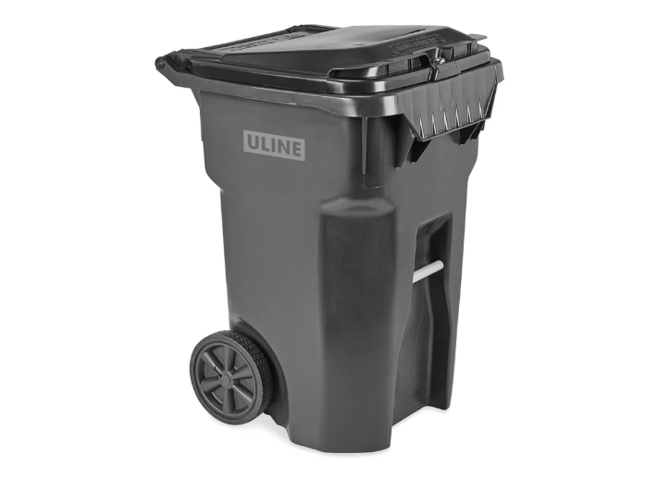
https://www.uline.com/
Figure 1: Latched Trash Containers

Table 4.1: [BMP] Inspection & Maintenance

ACTIVITY | FREQUENCY
Specify period when maintenance is required (e.g. Warranty Period, Ongoing, etc.)
[Specify inspection and maintenance activities and necessary equipment, be as specific as possible.] | [Specify when inspection or maintenance is required (e.g. Weekly, Biweekly, etc.). Include period over which activities must be completed, along with any specifics concerning when activity intervals should be adjusted.]
[Specify inspection and maintenance activities and necessary equipment, be as specific as possible.] | [Specify when inspection or maintenance is required (e.g. Weekly, Biweekly, etc.). Include period over which activities must be completed, along with any specifics concerning when activity intervals should be adjusted.]
[Specify inspection and maintenance activities and necessary equipment, be as specific as possible.] | [Specify when inspection or maintenance is required (e.g. Weekly, Biweekly, etc.). Include period over which activities must be completed, along with any specifics concerning when activity intervals should be adjusted.]

- Color to be used in Sections 5.1 and 6
Waste Disposal for Pets
Pet waste is a concern from a stormwater perspective because it can contaminate stormwater runoff with pathogens.
Pet owners should take care of their pet’s waste when it is produced, and site owners can help facilitate this process by providing bags and waste receptables. Site owners can help remind pet owners of the responsibility for pet waste disposal by putting up appropriate signage.
Site owners should ensure that there are bags available for pet owner use and the pet waste disposal containers are regularly emptied. Site owners should also ensure that signage is legible and in good condition.
https://www.petwasteeliminator.com/

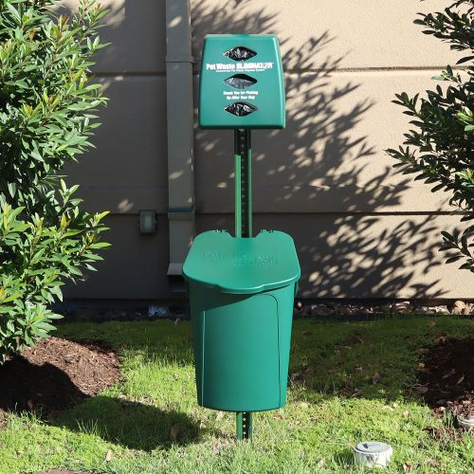
Figure 1: Pet Waste Bags and Receptacle

https://www.compliancesigns.com/
Figure 2: Pet Waste Disposal Signage

Table 4.2: [BMP] Inspection & Maintenance

ACTIVITY | FREQUENCY
Specify period when maintenance is required (e.g. Warranty Period, Ongoing, etc.)
[Specify inspection and maintenance activities and necessary equipment, be as specific as possible.] | [Specify when inspection or maintenance is required (e.g. Weekly, Biweekly, etc.). Include period over which activities must be completed, along with any specifics concerning when activity intervals should be adjusted.]
[Specify inspection and maintenance activities and necessary equipment, be as specific as possible.] | [Specify when inspection or maintenance is required (e.g. Weekly, Biweekly, etc.). Include period over which activities must be completed, along with any specifics concerning when activity intervals should be adjusted.]
[Specify inspection and maintenance activities and necessary equipment, be as specific as possible.] | [Specify when inspection or maintenance is required (e.g. Weekly, Biweekly, etc.). Include period over which activities must be completed, along with any specifics concerning when activity intervals should be adjusted.]

- Color to be used in Sections 5.1 and 6
Illegal Dumping into Catch Basins
Disposing, dumping, or any discharge of any substance other than stormwater into catch basins is harmful and can contaminate the sewer systems.
Site owners should ensure waste is not being disposed of improperly by monitoring on and around their site to avoid causing environmental damage or harm.

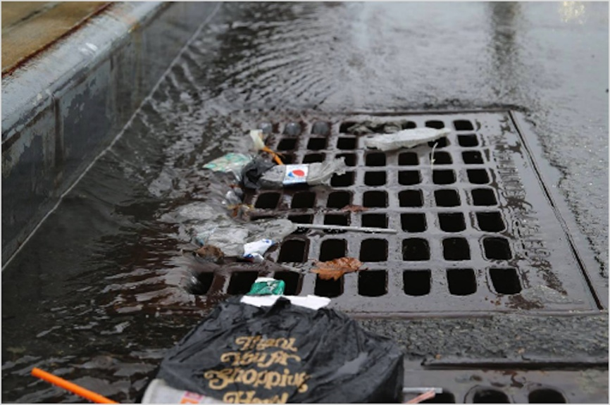
Figure 1: Monitoring of Illegal Dumping into Catch Basin
Table 4.3: [BMP] Inspection & Maintenance

ACTIVITY | FREQUENCY
Specify period when maintenance is required (e.g. Warranty Period, Ongoing, etc.)
[Specify inspection and maintenance activities and necessary equipment, be as specific as possible.] | [Specify when inspection or maintenance is required (e.g. Weekly, Biweekly, etc.). Include period over which activities must be completed, along with any specifics concerning when activity intervals should be adjusted.]
[Specify inspection and maintenance activities and necessary equipment, be as specific as possible.] | [Specify when inspection or maintenance is required (e.g. Weekly, Biweekly, etc.). Include period over which activities must be completed, along with any specifics concerning when activity intervals should be adjusted.]
[Specify inspection and maintenance activities and necessary equipment, be as specific as possible.] | [Specify when inspection or maintenance is required (e.g. Weekly, Biweekly, etc.). Include period over which activities must be completed, along with any specifics concerning when activity intervals should be adjusted.]

Example

SECTION 5 – BMP INSPECTION AND MAINTENANCE FORMS [MS4 Areas and NNI Requirements Only]

BMP Inspection Checklist [MS4 Areas and NNI Requirements Only]
Instructions:
One inspection checklist shall be created for all the BMPs listed in Section 4.1.

The O&M Manual developer shall include the following information, at a minimum, in the inspection checklist:
- Name of the BMP.
- Color that corresponds with the name of the BMP which was set in Section 4.2.
- Spaces where the following information can be written: name and signature of the inspector, contact information, date of inspection, address, weather conditions, location where the BMP is performed.
- A list of all the BMPs required for the developed site along with inspection activities and frequencies associated with each BMP. (Note that these components must be aligned with those included in the Inspection and Maintenance Tracker Form in section 5.3)
- Spaces where inspectors can mark the completion of each inspection activity and any associated observations.
- Include instructions for what to do with the completed inspection checklist. Instructions should reflect the following requirements: Inspector must fill out one (1) Inspection Checklist form per inspection visit. The Inspector must update the Inspection and Maintenance Tracker form in Section 5.3 after each inspection visit. The completed forms must be stored with the O&M Manual.

An example inspection checklist is shown on the following page for illustration purposes only and does not contain all of the required information. Applicants should create their own inspection checklists that are tailored to the design details of their project.
Remove instructions before submitting

BMP Inspection Checklist
Inspected by:  John Doe  X_____________________  Insert Phone Number  Insert Fax/Email |  |  |  | Site Address:  123-45 Example St., City, NY
Date of Inspection: 6/18/2023 |  |  |  | Weather: Sunny 85 degrees F
Location Description: Trash container located on play yard Southwest corner, Pet disposal container on play yard Southeast corner, Catch basins along the perimeter of the site
Frequency | Activity Item # | Inspection Items | Inspected?  (Y/N) | Follow Up Action Needed
Weekly | - 1. Latched or Heavy-Lidded Trash Containers
 | 1a. | Are the heavy lids on the trash containers? | Y | No Follow Up Action Required
 | 1b. | Are the trash lids and containers in good and functioning condition? | Y | No Follow Up Action Required
 | 1c. | Are the trash containers full? | Y | Container needs to be emptied
Weekly | - 2. Waste Disposal for Pets
 | 2a. | Are there pet waste disposal bags available? | Y | Pet waste disposal bags require refilling
 | 2b. | Is the pet waste container full? Does the lid seal properly? | Y | Container needs to be emptied
 | 2c. | Is pet waste disposal signage visible and legible? | Y | No Follow Up Action Required
 | 2d.
 | 2e.
 | 2f.
Weekly | - 3. Monitor for Illegal Dumping into Catch Basins
 | 3a. | Is there illegal waste visible in catch basins? | Y | No illegal waste is seen in catch basins
 | 3b.
ONCE INSPECTION IS COMPLETED:
- KEEP COMPLETED INSPECTION CHECKLIST IN O&M MANUAL
- FILL OUT INSPECTION AND MAINTENANCE TRACKER FORM

BMP Maintenance Checklist [MS4 Areas and NNI Requirements Only]

Instructions:
One maintenance checklist shall be created for all the BMPs listed in Section 4.1.

The O&M Manual developer shall include the following information, at a minimum, in the inspection checklist:
- Name of the BMP.
- Color that corresponds with the name of the BMP which was set in Section 4.2.
- Spaces where the following information can be written: name and signature of the inspector, contact information, date of inspection, address, and weather conditions.
- A list of all the BMPs required for the developed site along with maintenance activities and frequencies associated with each BMP. (Note that these components must be aligned with those included in the Inspection and Maintenance Tracker Form in section 5.3)
- Include instructions for what to do with the completed inspection checklist. Instructions should reflect the following requirements: Inspector must fill out one (1) Maintenance Checklist form per maintenance visit. The Inspector must update the Inspection and Maintenance Tracker form in Section 5.3 after each inspection visit. The completed forms must be stored with the O&M Manual.

An example maintenance checklist is shown on the following page for illustration purposes only and does not contain all of the required information. Applicants should create their own maintenance checklists that are tailored to the design details of their project.

Remove instructions before submitting

Monitor for Illegal Dumping into Catch Basins
Maintained by:  John Doe  X_____________________  Insert Phone Number  Insert Email |  | Site Address:  123-45 Example St., City, NY
Date of Maintenance: 6/30/2023 |  | Weather: Sunny 85 degrees F
FREQUENCY | MAINTENANCE ACTIVITY DESCRIPTION & NOTES | ACTIVITY PHOTO
Yearly | Catch basin cleaning | 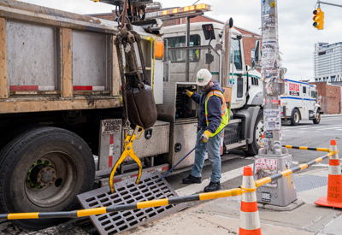
[Maintenance Frequency] | [Maintenance Activity Description]
ONCE MAINTENANCE ACTIVITY IS COMPLETED:
1) KEEP COMPLETED MAINTENANCE CHECKLIST IN O&M MANUAL
2) FILL OUT INSPECTION AND MAINTENANCE TRACKER FORM

BMP Inspection and Maintenance Tracker Form [MS4 Areas and NNI Requirements Only]
Instructions:
- The purpose of this form is to track when inspection and maintenance activities for each BMP throughout a single year.
- Frequency of activities are established in Section 4.2. These frequencies should be consistent with the frequency table in the inspection and maintenance tracker form.
- A single Inspection and Maintenance Tracker Form shall be used per year and be stored in the O&M Manual.
- The project name, location and year that the BMP Inspection & Maintenance Tracker Form will be used shall be filled out at the top of the form.
- When activities are completed, they should be recorded in the BMP Inspection & Maintenance Tracker Form.
- The “Action” column shall be filled out according to activity type (Inspection, Maintenance, or Follow Up)
  - Inspection activities (I) include those listed in Section 5.1.
  - Routine maintenance (M) includes scheduled tasks intended to ensure functionality and prevent issues.
  - Follow Up (F) actions include specific tasks performed in response to an identified issue or observation. Follow Up actions are identified during routine maintenance or inspections.
- The “Date” column shall be filled out according to the date when an inspection, maintenance, or follow up activity is completed.
- The “Notes” column shall be used to briefly record any observations made during inspection, maintenance, or follow up activities. This will help track potentially recurring issues. Additional sheets may be added for observations as required. Refer to New York City Stormwater Manual Chapter 5 for suggested maintenance activities and frequencies.
An example inspection and maintenance tracker form is shown on the following page for illustration purposes only and does not contain all of the required information. Applicants should create their own form that is tailored to their project.

Remove instructions before submitting

REQUIRED FREQUENCY
Activity Type | Latched or Heavy-Lidded Trash Containers | Waste Disposal for Pets | Illegal Dumping into Catch Basins
Inspection | WEEKLY | WEEKLY | WEEKLY
Maintenance | MONTHLY | MONTHLY | YEARLY
Follow Up | AS INDICATED IN SECTION 5.1
BMP INSPECTION AND MAINTENANCE TRACKER FORM
Year: 2023 Project Name: P.S. XYZ Green Infrastructure
Performed by: Contracted Company or Responsible Party Location: 123-45 Example St., City, NY
INSPECTION AND MAINTENANCE TRACKER: Fill out the table when Inspection or Maintenance is completed.
Latched or Heavy-Lidded Trash Containers |  |  | Waste Disposal for Pets |  |  | Illegal Dumping into Catch Basins
Action | Date | Notes | Action | Date | Notes | Action | Date | Notes
M | X/XX/XX
I | X/XX/XX
F | X/XX/XX
Key:
I – Inspection
M – Maintenance
F- Follow Up

SECTION 6 – MARKED UP AS-BUILTS

Instructions:
The O&M Manual developer shall compile SMP as-built site plans that include the following:
- SMP Location Map with SMPs & Collection System
  - SMP Type
  - SMP Function Type
  - SMP Footprint
  - Latitude and Longitude of each SMP
- As-Built Plans (refer to Project Close-Out Materials Checklist for required information)
  - As-Built Cover & Contributing Drainage Area
  - As-Built Drainage Utility Area
  - As-Built SMP Section/Detail Plans
- Planting/Landscape Plan
The O&M Manual developer will highlight the applicable SMPs and drainage structure connected directly to the SMP, and BMPs using the associated unique color designation. There may be occasions where drainage structures further upstream or downstream of the SMP will need to be highlighted and maintained to preserve the functionality of the SMP.
The purpose of this is to help the inspector and/or the maintenance personnel to know where on the site plan certain maintenance practices shall be performed.
An example of marked up as-built for the SMP Location Map is shown on the following page for illustration purposes only and do not contain all the required information. Applicants should prepare their own as-builts to reflect their constructed project.

As-Built Plans must be signed and sealed by a Qualified Professional.
Remove instructions before submitting

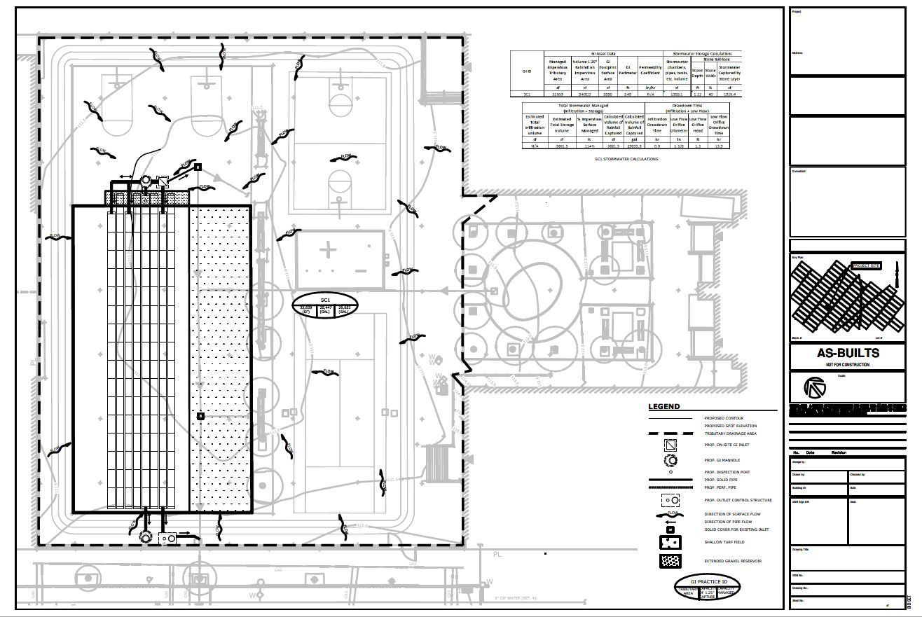
6.1 SMP Location Map
Note: Callouts correlate with the required list in the instructions.
Pet Waste Disposal Container
BMP No. 2
Latched Trash Container
BMP No. 1
Pet Waste Disposal Container
Latched Trash Container
Drainage Structures
Synthetic Turf Field
Stormwater Gallery
Stormwater Gallery
SMP Function
(##°##’##. ####” X,
##°##’##. ####” X)

Synthetic Turf Field
SMP Function
(##°##’##.####” X,
##°##’##.####” X)

Drainage Structure
DS ID No. OCS
Drainage Structure
DS ID No. GI Manhole #2
Drainage Structure
DS ID No. GI Inlet #1
Drainage Structure
DS ID No. GI Inlet #2
Drainage Structure
DS ID No. GI Manhole #1

c

a
LEGEND
b
d

Illegal Dumping into Catch Basins
Illegal Dumping into Catch Basins
BMP No. 3

6.2 As-Built Plans

INSERT AS-BUILT PLANS
(Refer to Project Close-Out Materials Checklist)
- As-Built Cover & Contributing Drainage Area
- As-Built Drainage Utility & SMP Plan

6.3 Planting/Landscaping Plans

