FIELD SAMPLING SUMMARY REPORT TEMPLATE
When excavation and off-site disposal of soils and/or dewatering are required during construction and NYCDDC’s Standard Specification for Handling, Transportation, and Disposal of Potential and Identified Contaminated and Hazardous Materials (Section 8.01 C2-Sampling and Testing of Contaminated/Potentially Hazardous Soil for Disposal Purposes) has been included in the Contract, the New York City Department of Design and Construction (NYCDDC) requires Contractors to retain an independent Environmental Consultant (hereafter identified as “Consultant”) to prepare a Field Sampling Plan (FSP) and Investigation Health and Safety Plan (IHASP) which will serve to characterize soils and/or groundwater to be excavated/removed for parameters typically requested by disposal facilities. Regarding soils, the data will be utilized to determine if the soil to be excavated is suitable for reuse or needs to be transported off-site for disposal as contaminated (non-hazardous) or contaminated (hazardous) soil. Regarding groundwater, the data will be utilized to determine proper disposal methods (either on-site or off-site) for groundwater and/or decontamination water generated during site investigation activities.
Following completion of the field sampling activities and receipt of corresponding analytical data reports from the laboratory, the Consultant will prepare a Field Sampling Summary Report (FSSR). The FSSR shall be submitted to the NYCDDC Office of Environmental and Hazmat Services (OEHS) [formerly referred to as Office of Environmental and Geotechnical Services (OEGS)] for review and acceptance. This FSSR Template is meant to be a guide to help Consultants with the development of an FSSR that is compliant with NYDDC rules and regulations.
This FSSR shall be completed in accordance with NYCDDC’s Standard Specification for Handling, Transportation, and Disposal of Potential and Identified Contaminated and Hazardous Materials (Section 8.01 C2 In-Situ and Ex-Situ Soil Sampling and Analysis for Waste Disposal Parameters)
INSTRUCTIONS FOR USING THE FSSR TEMPLATE
Each section of this FSSR Template includes instructions and fillable text fields denoted in blue. Read the instructions for each section before completing that section. The blue text indicates information to include in each text field. Click on the blue text and start typing. This FSSR Template is an editable document file, to which you may add tables and additional text. For sections of the FSSR that do not apply, insert “Not Applicable” in the text field, and check the “Not Applicable” box where available. Note that some sections may require only a brief description while others may require several pages of explanation. Any edits to black text should be completed using track changes.
REGULATORY REFERENCES
The following State and Local rules and regulations noted below are offered as references that can be viewed to assist with the completion of the IHASP Template. The list, along with hyperlinks to the regulatory references, is not all inclusive but offers some general guidance.
- NYSDEC Spill Guidance Manual
  - https://www.dec.ny.gov/regulations/2634.html
- NYSDEC CP-51 – Soil Cleanup Guidance Policy
  - https://www.dec.ny.gov/docs/remediation_hudson_pdf/cpsoil.pdf
- NYSDEC Spills Technology and Remediation Series (STARS) Guidance Documents
  - https://www.dec.ny.gov/regulations/2393.html
- NYSDEC DER-10 – Technical Guidance for Site Investigation and Remediation
  - https://www.dec.ny.gov/regulations/67386.html
- NYSDEC Soil Cleanup Objectives (SCOs)
  - https://www.dec.ny.gov/docs/remediation_hudson_pdf/part375.pdf
- NYSDEC Groundwater Quality Standards (GWQS)
  - https://www.dec.ny.gov/docs/water_pdf/togs111.pdf
- NYCDEP Limitations for Effluent to Sanitary and Combined Sewers
- https://www1.nyc.gov/assets/dep/downloads/pdf/about/water-and-sewer-forms/dewatering-wastewater-quality-control-application-for-discharges-over-10000-gallons-per-day.pdf
While the NYCDDC has made every effort to ensure the accuracy of all instructions contained in this FSSR Template, it is the Rules and Regulations of the City and State of New York, not the template, that govern your obligations with respect to the preparation of the FSSR and performance of the proposed field sampling activities.

Field Sampling Summary Report

FSSR Prepared for:
Insert Project Name
Insert Capital Project ID Number
Insert Project/Site Address/Location
Insert Project/Site Phone Number


New York City Department of Design and Construction
30-30 Thomson Ave, Queens, New York 11101

Insert Contractor Name
Insert Address, City, State, Zip Code

FSSR Prepared By:
Insert Company or Organization Name
Insert Contact Name
Insert Address, City, State, Zip Code
Insert Phone Number
Insert Fax/Email

FSSR Preparation Date:
Insert Date

FSSR Revision Date:
Insert Date

Estimated Project Start and End Dates:
Insert Start Date — Insert Completion Date

TABLE OF CONTENTS
Acronyms i
Revision Log iii
Certification Statement iv
SECTION 1: INTRODUCTION AND PROJECT PURPOSE 1
1.1 General 1
1.2 Purpose 1
1.3 Project Organization and Responsibilities 1
1.4 Site History 3
SECTION 2: SCOPE OF WORK 4
2.1 Field Sampling Scope of Work 4
2.2 Investigation Health and Safety Plan 4
SECTION 3: PHYSICAL SETTING 5
3.1 Project Area and Site Location Description 5
3.2 Topography and Drainage 9
SECTION 4: SOIL QUALITY INVESTIGATION (IF APPLICABLE) 10
SECTION 5: GROUNDWATER QUALITY INVESTIGATION (IF APPLICABLE) 15
SECTION 6: LABORATORY ANALYSIS 18
6.1 Lab Qualifications/Certifications 18
SECTION 7: RESULTS AND CONCLUSIONS 19
7.1 Soil Sample Results (if applicable) 19
7.2 Groundwater Sample Results (if applicable) 20
7.3 Conclusions 20
SECTION 8: REPORT CERTIFICATION 21

Figures
Figure 1 Project Location Map
Figure 2 Aerial View Map
Figure 3 Sample Location Map

Tables
Table 1 Sampling Summary (including Frequency and Analytical Methods)
Table 2 Soil Analytical Results (NYSDEC Unrestricted Use SCOs) (if applicable)
Table 3 Soil Analytical Results (NYSDEC Restricted Use SCOs) (if applicable)
Table 4 Soil Analytical Results (RCRA TCLP Criteria) (if applicable)
Table 5 Groundwater Analytical Results (NYSDEC GWQC) (if applicable)
Table 6 Groundwater Analytical Results (NYCDEP Sewer Effluent Limitations) (if applicable)

Appendices
Appendix A Historic Site Investigation Documents (if applicable)
Appendix B Field Book Contents
Appendix C Laboratory Qualifications
Appendix D Laboratory Analytical Results - Soil (if applicable)
Appendix E Laboratory Analytical Results – Groundwater (if applicable)
Appendix F Published Cleanup Criteria (Soil & Groundwater)

Acronyms
The following acronyms are referenced in this FSSR template. Any additional acronyms included in the FSSR should be added to the table below.
Item | Description
BWT | Bureau of Wastewater Treatment
CGAs | Combustible gas analyzers
COC | Chain-of-custody
ELAP | Environmental Laboratory Approval Program
EPH | Extractable Petroleum Hydrocarbons
FIDs | Flame ionizations detectors
FSP | Field Sampling Plan
FSSR | Field Sampling Summary Report
GWQS | Groundwater Quality Standards
HSC | Health and Safety Coordinator
HSGs | Hydrologic soil groups
HSO | Health and Safety Officer
HSP | Health and Safety Plan
IHASP | Investigation Health and Safety Plan
NYCDDC | New York City Department of Design and Construction
NYCDEP | New York City Department of Environmental Protection
NYSDEC | New York State Department of Environmental Conservation
NYSDOH | New York State Department of Health
OEHS | NYCDDC Office of Environmental and Hazmat Services
OEGS | NYCDDC Office of Environmental and Geotechnical Services
OSHA | Occupational Safety and Health Administration
PCBs | Polychlorinated Biphenyls
PID | Photoionization detected
QAPP | Quality Assurance Project Plan
QA/QC | Quality Assurance/Quality Control
RCRA | Resource Conservation and Recovery Act
SCOs | Soil Cleanup Objectives
STARS | Spills Technology and Remediation Series
SVOCs | Semi-Volatile Organic Compounds
TAL | Target Analyte List
TAT | Turn-around time
TCLP | Toxicity Characteristic Leaching Procedure
USGS | U.S. Geological Survey
VOC | Volatile organic compound
WHP | Waste Handling Plan

Revision Log
The following revision log should be completed with the initial submission and subsequent revisions. The revision date noting two digits for the month, two digits for the day, and four digits for the year (i.e., 00/00/0000) should be entered in the Date column. The Revision Number should offer revision number with two digits (i.e., 00, 01, 02, 03 – noting 00 as the initial submission) with FSSR as the descriptor (i.e., FSSR-00, FSSR-01, FSSR-02). Revision Description column should contain a brief description of changes and/or initial submission.
Date | Revision Number | Description
00/00/0000 | FSSR-00 | Initial submission for NYCDDC for review

Certification Statement
FSSR Certification by Insert Company of Organization Name
- Insert Company of Organization Name certifies that this document dated Insert Date and all information included is true, accurate, and complete to the best of my professional knowledge and judgement; and

- This FSSR has been prepared in accordance with all applicable statutes and regulations; and

- This FSSR has been prepared in conformance with NYCDDC Specifications for Handling, Transportation, and Disposal of Potential and Identified Contaminated and Hazardous Materials (Item 8.01)

Insert Author’s Signature

Insert Author’s Name / Affiliation / Date

INTRODUCTION AND PROJECT PURPOSE
Instructions:
- In this section, present the overall project purpose and description of the investigation activities performed to characterize the anticipated waste to be generated (both soil and/or groundwater). If waste soil or groundwater requiring off-site disposal will not be generated (and not investigated), delete the sections/text below as necessary.

- As required by NYCDDC Specification Item 8.01 C1.1(C), the Contractor must retain an independent Environmental Consultant to obtain all permits, prepare the plans required in Specification Section 8.01, and perform all field screening and sampling. The Independent Consultant must be approved under NYCDDC’s Request for Approval of Subcontractors (RFAS) process and demonstrate the minimum experience and requirements listed in the Specification.

General
At the request of Contractor Name and Address, Independent Consultant Name and Address prepared this Field Sampling Summary Report (FSSR) for submittal to the New York City Department of Design and Construction (NYCDDC). This FSSR summarizes the in-situ/ex-situ soil sampling activities (and groundwater sampling activities) performed on Enter Date of Sampling Activities. The soil and/or groundwater sampling activities were performed to characterize subsurface (or stockpiled soils) and/or groundwater (or surface water) that will be generated during the NYCDDC Construction Project Name that will require off-site disposal. The soil and/or groundwater sampling activities were performed in accordance with the NYCDDC Accepted Field Sampling Plan (FSP) dated Date of Accepted FSP and NYCDDC Specification Section 8.01 C2.

Purpose
Include a summary of the project construction activities that will generate impacted soil and/or groundwater that required the performance of the sampling (characterization) activities summarized in this FSSR.

Project Organization and Responsibilities
Prior to the start of the project, the overall responsibilities for project personnel and subcontractors were established, including the chain of command. The personnel and organizations critical to the performance of the site investigation activities at the site and their respective responsibilities are listed below.
Instructions:
If additional personnel and organizations critical to the planned site investigation activities are anticipated (including additional subcontractors, laboratories, etc.), please include additional rows in the below table.

Environmental Project Director – The Project Director will be responsible for communicating with the Client and have overall responsibility for the project. | Project Director Name, Company  Address  Phone Number  E-mail
Environmental Project Manager - The Project Manager will have the overall responsibility of coordinating the project and will be responsible for assigning qualified field personnel, including the project support staff such as the Health and Safety Coordinator. | Project Manager Name, Company  Address  Phone Number  E-mail
Health and Safety Coordinator - The Health and Safety Coordinator (HSC) is responsible for developing the IHASP and will be responsible for providing consultation on all health and safety related issues as they may arise in the field. Any alterations and/or modifications to the IHASP must be accepted by the HSC. | HSC Name, Company  Address  Phone Number  E-mail
Site Health and Safety Officer - The Site Health and Safety Officer (HSO) will be primarily responsible for the implementation of the IHASP at the project site. The HSO will also assure that project personnel are aware of the provisions of the IHASP and are instructed in the safe work practices and emergency procedures; be present at the site at all times when the project work is going on unless the project task does not necessitate his presence; and communicate with the Project Manager and HSC for any changes and/or modifications required in the IHASP. The HSO has the responsibility and the authority to shut down unsafe operations as and when they arise. | HSO Name, Company  Address  Phone Number  E-mail
Field Staff – List Field Staff (geologists, technicians, etc. separately. | Field Staff Name, Company  Role/Title  Address  Phone Number  E-mail
Soil Boring Subcontractor – If in-situ soil borings are to be installed, the boring contractor and contact shall be identified. | Representative Name, Company  Address  Phone Number  E-mail
Analytical Laboratory – The analytical laboratory to be utilized for soil and/or groundwater analysis | Laboratory Name, Company  Address  Phone Number  E-mail

Site History
Instructions:
- In this section, summarize the history of the site up to and including the need for the subject field sampling activities. Include reference to all historic sources.
- If historic sources are acquired and contain soil and/or groundwater analytical data pertinent to the subject field sampling scope of work, those sources should be included in Appendix A.
Include Site History Summary

SCOPE OF WORK

Field Sampling Scope of Work
Instructions: The Field Sampling Scope of Work shall be performed in accordance with the NYCDDC accepted FSP.
- Include a general summary of the Field Sampling Scope of Work performed and how it varied (if at all) from the Scope of Work Presented in the FSP.
- Provide a general description of the field sampling activities performed at the site.
- Indicate the type of construction site, past, existing and proposed land use.
- Include natural and constructed features of the site.
- Provide a list and description of potential pollutant-generating activities (e.g., bulk petroleum storage, hazardous material storage and usage, etc.) currently used or used in the past and where the usage occurred on-site that could direct the selection of field sample locations.
Include Field Sampling Scope of Work

Investigation Health and Safety Plan
Instructions:
The Field Sampling Scope of Work shall be performed in accordance with the requirements of the NYCDDC accepted IHASP). Include the text below.
The subject field sampling activities summarized in this report were performed in accordance with the requirements of the NYCDDC accepted Investigation Health and Safety Plan (IHASP) dated Enter Date of IHASP.

PHYSICAL SETTING

Project Area and Site Location Description
Instructions:
- In this section, compile basic site information. When completing this section make sure to confirm site location information.
- Following this section is an 8 ½ “ by 11” portrait border template to be utilized for the preparation of Figure 1 and 2.

Project Name and Address
Project/ Site Name: Insert Text Here
Project Street/ Location: Insert Text Here
City: Insert Text Here
State: New York
Zip Code: Insert Text Here
Borough: Insert Text Here
Block(s) and Lot(s): Insert Text Here
DEC Region: 2
Business Days and hours for the project: Insert Text Here

Project Latitude/ Longitude
Latitude: _ _._ _ _ _ _ _ _ _ ° N
(Decimal degrees)
Longitude: -_ _._ _ _ _ _ _ _ _ ° W
(Decimal degrees)
Latitude/longitude data source:
☐ MAP ☐ GPS ☐ OTHER (Please specify): Insert Text Here
Horizontal Reference Datum: ☐ NAD 27 ☐ NAD 83 ☐ WGS 85
History of Construction Site (check all that apply):
☐ Single-Family Residential ☐ Multi-Family Residential ☐ Commercial ☐ Industrial
☐ Institutional ☐ Highway or Road ☐ Utility ☐ Other: Insert Text Here
General Site Description
Insert Brief Description of Site
Size of Construction Site
Area of Property or Corridor Length | Insert Area of Property (in acres) or insert corridor length (in feet)
A Project Location Map is included as Figure 1. An Aerial View Map is included as Figure 2.
Site Limitations/Assessment
Instructions:
Provide any site limitations that may affect the proposed site redevelopment activities and planned field sampling scope of work, including but not limited to watershed impairments, state or federal wetlands, etc. Describe all permits that may be required to implement the proposed site redevelopment project and proposed field sampling scope of work.
Insert Text Here
Known Soil Characteristics
Instructions:
Provide a description of soil characteristics that may impact sample locations, sampling strategy, and/or analytical results. Soil characteristics to assess may include (at a minimum) hydrologic soil groups (HSGs), slope classifications, porosity, bulk density, organic content, and hydraulic conductivity. Make reference (if applicable) to historic data sources documenting the soil characteristics. Include and make reference to historic data sources in Appendix A.

Insert Text Here
Known Groundwater Characteristics
Instructions:
Provide a description of groundwater characteristics that may impact sample locations, sampling strategy, and/or analytical results. Groundwater characteristics to assess may include (at a minimum) temperature, turbidity, dissolved oxygen, salt content, pH, transmissivity, conductivity, recharge, and flow direction. Make reference (if applicable) to historic data sources documenting groundwater characteristics. Include and make reference to historic data sources in Appendix A.

Insert Text Here
INSERT NEW FIGURE 1 CONTAINING THE PROJECT NAME, CAPITAL PROJECT ID AND ADDRESS
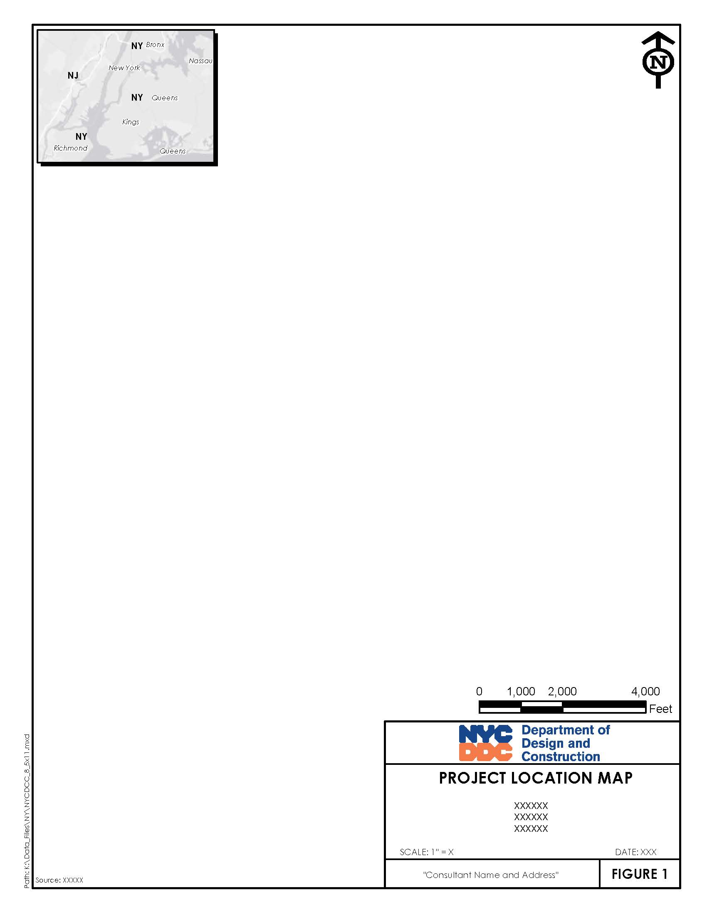

Topography and Drainage
Instructions:
In this section, summarize topography and drainage of project area and areas to be sampled (soil and/or groundwater) that could impact sampling locations and results.
Insert Topography and Drainage Summary

SOIL QUALITY INVESTIGATION (IF APPLICABLE)
Instructions:
- In this section, describe the soil sampling methodology including whether soils were sampled in-situ, or from excavated stockpiles). Choose the content below for either in-situ (via soil borings) or ex-situ, via stockpile sampling. Delete the content not needed.
- The number of soil samples to collect for waste characterization purposes is ultimately up to the selected, off-site disposal facility, including sampling frequency. The below methodology assumes a conservative sampling frequency of one soil sample for every 500 cubic yards (750 tons) of soil to be excavated/stockpiled. Modify this frequency, as necessary, based on the actual number of soil samples collected.
- The actual field sample locations (both soil and groundwater) shall be referenced and shown on Figure 3 and summarized on Table 1.
- Sample analytes are ultimately dependent on the selected disposal facility. The analyte list presented below is meant to be a guide based on typical required waste disposal parameters. Modify the analyte list accordingly based on the requirements of the anticipated/selected disposal facility. If a disposal facility is not yet known, indicate as such and state that additional analytes may be required based on selected disposal facility requirements.
- Following this section is an 11“ by 17” landscape border template to be utilized for the preparation of Figure 3.

(Check one that applies):
☐ Soil quality investigation was performed
☐ Not Applicable
In-Situ Soil Sampling (Soil Borings)
The purpose of the in-situ soil sampling activities performed was to characterize soils (to be excavated) for disposal (or potential reuse) options. According to findings of prior investigation activities, Describe anticipated/known soil quality data from known sources.
All waste characterization soil sampling was performed in accordance with NYSDEC sampling guidelines and protocols and NYCDDC Specification Item 8.01 C2.1.
A total of Insert Text Here cubic yards of soil is anticipated to be excavated and transported off-site for reuse/disposal. Insert Number Here soil samples (one per boring) were collected at a rate of one sample for every 500 cubic yards. The borings (identified as Insert sample IDs Here) were installed equidistant from each other, within the planned area of excavation as shown on Figure 3.
Borings were installed to a depth of Insert Text Here based on the planned depth of excavation. Each boring was screened with a photoionization detected (PID) for potential signs of volatile contamination. One discrete sample was collected from the 6-inch interval within the depth of the soil boring exhibiting the highest PID reading and or visual/olfactory evidence of potential contamination for volatile organic compound (VOC) analysis. If no signs of potential contamination were observed, the discrete VOC sample was collected from the 6-inch interval above the bottom of the proposed excavation or the 6-inch interval above the water table, if encountered. A composite sample from the remaining boring depth was collected and analyzed for the remaining analytes listed below:
- Semi-Volatile Organic Compounds (SVOCs)
- Pesticides
- Herbicides
- Polychlorinated Biphenyls (PCBs)
- Extractable Petroleum Hydrocarbons (EPH)
- Target Analyte List (TAL) Metals (including Hexavalent Chromium and Cyanide)
- Resource Conservation and Recovery Act (RCRA) characteristics (including ignitability, corrosivity, reactivity (sulfide and cyanide))
- Full Toxicity Characteristic Leaching Procedure (TCLP) analysis including VOCs, SVOCs, pesticides, herbicides, and metals
A summary of the sample analyses to be performed (including location, frequency, and analytical methods) is included as Table 1.
Further In-situ Composite Sampling Instructions:
- If the planned depth of excavation is six feet or less, the composite sample collected will be a composite of the entire remaining soil column once the discrete VOC sample is collected. If the depth of excavation is greater than six feet, each composite will be generated from five, six-inch intervals collected from various depths throughout the depth of each boring.
- If the planned excavation depth is greater than six feet, modify the sampling language above accordingly.
Insert Contractor Name contacted the NY Dig Safe Hotline (811) at least two but not more than ten working days, not including the date of the call, prior to the start of the soil boring activities to request mark out underground utilities in the area and adhered to all requirements of 16 NYCRR Part 753 during borings. Insert Contractor Name also acquired all necessary permits that were required to install the subject borings. Each boring location was cordoned off from pedestrian traffic via orange safety cones until the boring activities were complete.
All soil cuttings were returned to the borehole of origin. Each borehole was then backfilled to grade with bentonite clay. Following backfilling, each borehole was returned to pre-investigation condition (seeded, concrete, asphalt, etc.).
If site/project conditions required drumming of excess soils, describe said requirements and drumming operations performed here along with any additional sampling and disposal procedures required.
All sample containers were marked and identified with legible sample labels including project name, sample location, sample number, date and time of sampling, preservation method, and other information that may be useful in determining the sample characteristics. Chain-of-custody (COC) procedures were followed from laboratory issuance of the sample containers through laboratory receipt of the samples.
All sampling procedures and observations were recorded in a bound logbook. The field book will be turned over to NYCDDC in good condition upon completion of the work. A legible copy of the field book contents is included as Appendix B for reference. The following information was recorded in the field book:
- Sample identification number
- Sample location
- Field observations
- Sample type
- Required analyses
- Date/time of sample collection
- Collector’s name
- Sampling procedures and equipment utilized
- Date sent to laboratory and name of laboratory
Only dedicated sampling equipment was utilized to collect the samples. All sampling equipment was decontaminated before being brought to the site and properly disposed of after use.
Ex-Situ Soil Sampling (Stockpile Sampling)
The purpose of the proposed ex-situ soil stockpile sampling activities was to characterize excavated soils for disposal (or potential reuse) options. According to findings of prior investigation activities, Insert description of anticipated/known soil quality data from known sources .
All waste characterization soil sampling was performed in accordance with NYSDEC sampling guidelines and protocols and NYCDDC Specification Item 8.01 C2.1.
A total of Insert Text Here cubic yards of soil has been excavated requiring characterization for off-site reuse/disposal. Insert Number Here composite soil samples were collected at a rate of one sample for every 500 cubic yards. Each composite sampled consisted of five (5) grab samples collected from various locations and depths through the stockpile, at least two feet below the stockpile surface. The locations of each discrete grab samples (including naming convention to identify each parent composite sample) is shown on Figure 3.
Each discrete grab sample collected was screened with a photoionization detected (PID) for potential signs of volatile contamination. The discrete grab sample exhibiting the highest PID reading and or visual/olfactory evidence of potential contamination used to generate each composite was analyzed for volatile organic compound (VOC) analysis. If no signs of potential contamination are observed, the discrete VOC sample was randomly selected. Each composite sample was also analyzed for the remaining analytes listed below:
- Semi-Volatile Organic Compounds (SVOCs)
- Pesticides
- Herbicides
- Polychlorinated Biphenyls (PCBs)
- Extractable Petroleum Hydrocarbons (EPH)
- Target Analyte List (TAL) Metals (including Hexavalent Chromium and Cyanide)
- RCRA characteristics (including ignitability, corrosivity, reactivity (sulfide and cyanide))
- Full Toxicity Characteristic Leaching Procedure (TCLP) analysis including VOCs, SVOCs, pesticides, herbicides, and metals
A summary of the sample analyses performed (including location, frequency, and analytical methods) is included as Table 1.
For drummed soils, one (1) composite sample was collected for every 10 drums of excavated soil (assuming 55-gallon drum size). One discrete drum sample was collected for VOC analysis. A composite sample was generated from discrete samples collected from each drum and analyzed for the remaining analytes listed above.
Add to this section accordingly if drummed soils are being characterized.
All sample containers were marked and identified with legible sample labels including project name, sample location, sample number, date and time of sampling, preservation method, and other information useful in determining the sample characteristics. Chain-of-custody (COC) procedures were followed from laboratory issuance of the sample containers through laboratory receipt of the samples.
All sampling procedures and observations were recorded in a bound logbook. The field book will be turned over to NYCDDC in good condition upon completion of the work. A legible copy of the field book contents is included as Appendix B for reference. The following information was recorded in the field book:
- Sample identification number
- Sample location
- Field observations
- Sample type
- Required analyses
- Date/time of sample collection
- Collector’s name
- Sampling procedures and equipment utilized
- Date sent to laboratory and name of laboratory
Only dedicated sampling equipment was utilized to collect the samples. All sampling equipment was decontaminated before being brought to the site and properly disposed of after use.
INSERT NEW FIGURE 2 CONTAINING THE PROJECT NAME, CAPITAL PROJECT ID AND ADDRESS
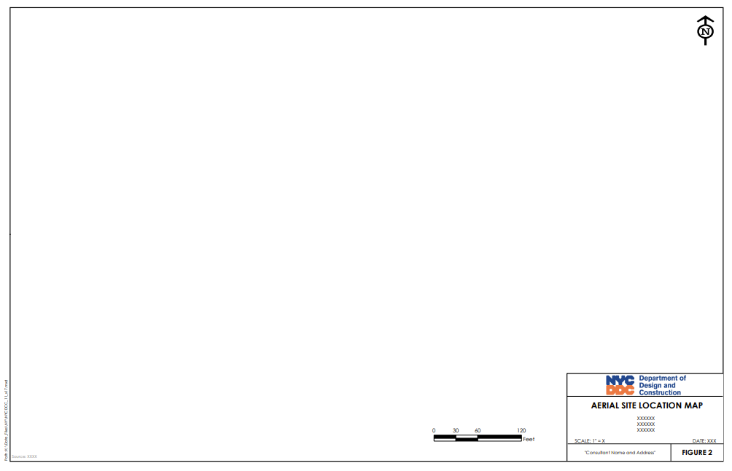

GROUNDWATER QUALITY INVESTIGATION (IF APPLICABLE)
Instructions:
- In this section, describe the groundwater sampling methodology preformed if the disposal of groundwater or decontamination water is anticipated during construction operations. If the generation of groundwater or decontamination water is not anticipated, this section can be deleted.
- The most cost-effective disposal method and the preference of NYCDDC is to discharge accumulated groundwater and decontamination water directly to the City’s storm or combined storm/sanitary sewer system. The text below assumes this disposal method. Written approval from NYCDDC is required for any other off-site disposal option. All other waste disposal options shall be presented to NYCDDC in a Waste Handling Plan (WHP) to be prepared under separate cover.
- If another off-site disposal method is chosen, replace the below text/groundwater sampling methodology with that required by the selected disposal method/facility.
(Check one that applies):
☐ Groundwater quality investigation was performed
☐ Not Applicable
Groundwater was sampled and analyzed to evaluate if it is suitable for discharge to the City’s storm or combined storm/sanitary sewer system. If determined to be suitable for discharge to the City’s sewer system, periodic effluent sampling will be required to confirm that the groundwater discharge remains in compliance with NYCDEP Sewer Effluent Limitations. If discharge to the sewer system is approved, discharge flow rates, periodic effluent sampling, and other discharge requirements will be conveyed in a Sewer Discharge Permit to be issued by NYCDDC. As required by NYCDDC Specification Section 8.01 W1.1, Insert Contractor Name will be required to retain a Dewatering/Water Treatment Specialist and laboratory to conduct continued testing as required by the Sewer Discharge Permit to be issued.
Describe groundwater sample locations, quantity, and method of collection
Groundwater sample locations are shown on Figure 3. Groundwater samples were collected to assist in determining discharge/disposal requirements for the groundwater and/or decontamination water generated during the proposed construction activities. The groundwater sample/s collected were analyzed for New York City Department of Environmental Protection (NYCDEP) Bureau of Wastewater Treatment (BWT) Sanitary/Combined Sewer Effluent Limitation Parameters including the following:
Parameter Analytical Method
VOCs EPA 624
SVOCs EPA 625
PCB 608 EPA 608
SGT-HEM (Non-Polar Material) EPA 1664B
Flash Point EPA 1010
Mercury 245.1 rev3.0
Metals-Five (Cd,Pb,Ni,Cu,Zn) 200.7
Cr (Hexavalent-24 hr) SM 3500-Cr B
Total Suspended Solids SM2540D-11
Carbonaceous BOD-5 Day SM5210 B-11
Chloride 300.0 rev2.1
Total Kjeldahl Nitrogen EPA 351
Nitrite-N 300.0 rev2.1
Nitrate-N 300.o rev2.1
Total Solids SM2540B-11
pH SM4500-H+B11
As the planned disposal method of the groundwater and/or decontamination water will be direct discharge to the City’s sanitary/combined sewer system, detected analyte concentrations were compared to the NYSDEC Groundwater Quality Standards (GWQS) and NYCDEP BWT Daily Effluent Limits (last updated May 1, 2005). A summary of the sample analyses performed (including location, frequency, and analytical methods) is included as Table 1.
All sample containers were marked and identified with legible sample labels including project name, sample location, sample number, date and time of sampling, preservation method, and other information useful in determining the sample characteristics. Chain-of-custody (COC) procedures were followed from laboratory issuance of the sample containers through laboratory receipt of the samples.
All sampling procedures and observations were recorded in a bound logbook. The field book will be turned over to NYCDDC in good condition upon completion of the work. A legible copy of the field book contents is included as Appendix B for reference. The following information was recorded in the field book:
- Sample identification number
- Sample location
- Field observations
- Sample type
- Required analyses
- Date/time of sample collection
- Collector’s name
- Sampling procedures and equipment utilized
- Date sent to laboratory and name of laboratory
Only dedicated sampling equipment was utilized to collect the samples. All sampling equipment was decontaminated before being brought to the site and properly disposed of after use.
INSERT NEW FIGURE 3 CONTAINING THE PROJECT NAME, CAPITAL PROJECT ID AND ADDRESS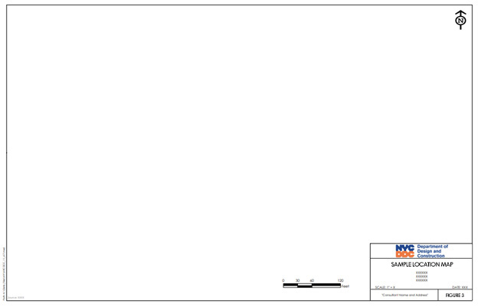

LABORATORY ANALYSIS

Lab Qualifications/Certifications
Instructions:
- In this section, describe the analytical laboratory selected to analyze the soil and/or groundwater samples to be collected. Include the laboratory name, address, and contact name and phone number.
- The selected laboratory must be certified by the New York State Department of Health (NYSDOH) Environmental Laboratory Approval Program (ELAP).
- Also include description of laboratory protocols, planned analytical suite, and laboratory turn-around time (TAT). Modify the below language as necessary based on the selected analytical laboratory.

Soil and/or groundwater samples were analyzed by Insert Laboratory Name. The laboratory’s contact information is as follows:
Laboratory Name: Insert Text Here
Laboratory Address: Insert Text Here
Laboratory Contact Name: Insert Text Here
Laboratory Contact Phone Number: Insert Text Here
As required by contract specifications, Insert Laboratory Name is a NYSDOH ELAP certified laboratory (NY ELAP No. Insert Laboratory Name). Copies of Insert Laboratory Name laboratory certifications are included in Appendix C for reference.
Insert Laboratory Name provided analytical results in a Insert approved TAT turn-around time (TAT).
Final analytical data reports for the soil samples collected are included in Appendix D. Final Analytical data reports for the groundwater samples collected are included in Appendix E.

RESULTS AND CONCLUSIONS
Instructions:
- In this section, summarize the analytical results of the soil and/or groundwater samples collected.
- Soil sample data shall be compared to applicable NYSDEC Part 375.6 Soil Cleanup Objectives (SCOs) and RCRA TCLP limits, 40 CFR Section 261. If soil is to be disposed of in a facility outside of the State of New York, the soil sampling data shall also be compared to the applicable regulatory criteria established by the state in which the disposal facility is located.
- Groundwater sample data shall be compared to applicable NYSDEC Part 701 Groundwater Quality Standards (GWQSs) and if applicable, NYCDEP Sewer Effluent Limitations. If another groundwater disposed method is selected (whether within NYS or elsewhere), the groundwater sampling data shall also be compared to the applicable regulatory criteria established by the state and local government in which the disposal facility is located.
- Separate analytical tables shall be prepared for each area of concern investigated. Regarding soil samples, separate analytical tables shall also be prepared comparing analytical results to both Unrestricted Use SCOs, Restricted Use SCOs, and TCLP, as applicable. Regarding groundwater, separate analytical tables shall be prepared comparing analytical results to GWQS and NYCDEP Sewer Effluent Limitations, as applicable.
- Applicable City, State, and Federal Cleanup Criteria tables shall also be referenced and included in Appendix F.
- Based on the analytical results obtained during the subject field sampling activities, conclusions shall be presented on both available and/or selected disposal methods (including on-site reuse).
- The text below shall be modified accordingly based on the soil and/or groundwater samples collected, the analytical data received, and the selected waste disposal method.

Soil Sample Results (if applicable)
(Check one that applies):
☐ Soil sample results collected
☐ Not Applicable
Insert description of soil characteristics (identified historically and/or during current investigation activities) that could impact the analytical results currently being reported.
Insert description of field screening results including visual observations, olfactory observations, PID readings, and any other signs of potential impacts to site soils.
Insert summary of soil analytical results. Include reference to those samples that had all analyte concentrations below applicable Criteria and in excess of applicable Criteria.
Insert description of typical/likely/confirmed contaminant sources based on analytical data sources.
The locations of each soil sample collected are shown on Figure 3. Soil sample analytical results are summarized in Tables 2, 3, and 4. Laboratory soil analytical reports are included in Appendix E Regulatory cleanup criteria tables are included in Appendix F.

Groundwater Sample Results (if applicable)
(Check one that applies):
☐ Groundwater sample results collected
☐ Not Applicable
Insert description of groundwater characteristics (identified historically and/or during current investigation activities) that could impact the analytical results currently being reported.
Insert description of field screening results including visual observations, olfactory observations, PID readings, and any other signs of potential impacts to site groundwater (and surface water if applicable).
Insert summary of groundwater analytical results. Include reference to those samples that had all analyte concentrations below applicable Criteria and in excess of applicable Criteria.
Insert description of typical/likely/confirmed contaminant sources based on analytical data sources.
The locations of each groundwater sample collected are shown on Figure 3. Groundwater sample analytical results are summarized in Tables 5 and 6. Laboratory groundwater analytical reports are included in Appendix E. Regulatory cleanup criteria tables are included in Appendix F.

Conclusions
Based on the analytical data received, convey the available and selected waste disposal options for both soil and/or groundwater. This discussion should focus on each area of concern investigated at the site. Based on the selected disposal method/s, discuss additional waste disposal sampling that may be required (including continued sampling that may be required by a selected disposal facility).

REPORT CERTIFICATION
Instructions:
Complete the below Certification Statement and modify the text accordingly based on the actual soil and/or groundwater sampling activities performed.

Certification Statement
Report Certification by Insert Company of Organization Name
- Insert Company of Organization Name certifies that this FSSR dated Insert Date and all information included is true, accurate, and complete to the best of my professional knowledge and judgement; and

- This FSSR has been prepared in accordance with all applicable statutes and regulations; and

- This FSSR has been prepared in conformance with NYCDDC Specifications for Handling, Transportation, and Disposal of Potential and Identified Contaminated and Hazardous Materials (Item 8.01)

Author’s Signature

Author’s Name / Affiliation / Date

FIGURES
Instructions:
- The Consultant shall include the following three figures in the Field Sampling Report:
- Figure 1 Project Location Map
- Figure 2 Aerial View Map
- Figure 3 Sample Location Map

- Utilize the border templates included in Sections 3.1 and 4.
- Each of the figures shall include the Project Name and Project Address.
- Figure 1 shall include the most recently published U.S. Geological Survey (USGS) Topographic Map (the name and date of which to be included in the title block) centered on the project site.
- Figure 2 shall include an aerial photograph centered on the subject site showing current site conditions. The site boundary shall be shown on the aerial photograph along with a north arrow and applicable scale.
- Figure 3 shall show the entire site (within the same site boundary as shown on Figure 2), along with a north arrow and applicable scale. All proposed sample locations (both soil and/or groundwater) shall be shown along with corresponding sample IDs.

TABLE 1
Sampling Summary
AOC Name
Site Name
Site Address
AOC | Boring ID | Location | Sample ID | Sample Depth (ft) | Parameter (Methodology)

TABLE 2
Soil Analytical Results (NYSDEC Unrestricted Use SCOs)
AOC Name
Site Name
Site Address
 |  |  | Client ID:
 |  |  | Lab ID:
 |  |  | Collection Date:
 |  |  | Sample Matrix:
 |  |  | Sample Units: | ppm |  | ppm |  | ppm |  | ppm |  | ppm |  | ppm |  | ppm |  | ppm
Containment | CAS # | Unrestricted Use SCO (ppm) |  | Result | MDL | Result | MDL | Result | MDL | Result | MDL | Result | MDL | Result | MDL | Result | MDL | Result | MDL

TABLE 3
Soil Analytical Results (NYSDEC Restricted Use SCOs)
AOC Name
Site Name
Site Address
 |  |  |  |  |  |  |  | Client ID:
 |  |  |  |  |  |  |  | Lab ID:
 |  |  |  |  |  |  |  | Collection Date:
 |  |  |  |  |  |  |  | Sample Matrix:
 |  |  |  |  |  |  |  | Sample Units: | ppm |  | ppm |  | ppm |  | ppm |  | ppm |  | ppm
 |  | Protection of Public Health (ppm)
Containment | CAS # | Residential | Restricted Residential | Commercial | Industrial | Protection of Ecological Resources | Protection of Groundwater |  | Result | MDL | Result | MDL | Result | MDL | Result | MDL | Result | MDL | Result | MDL

TABLE 4
AOC Name
Site Name
Site Address
 |  |  |  | Client ID:
 |  |  |  | Lab ID:
 |  |  |  | Collection Date:
 |  |  |  | Sample Matrix:
 |  |  |  | Sample Units: | mg/l |  | mg/l |  | mg/l |  | mg/l |  | mg/l |  | mg/l |  | mg/l |  | mg/l
Containment | CAS # | EPA HW No. | TCLP Limit (mg/l) |  | Result | MDL | Result | MDL | Result | MDL | Result | MDL | Result | MDL | Result | MDL | Result | MDL | Result | MDL

TABLE 5
Groundwater Analytical Results (NYSDEC Groundwater Quality Standards (GWQS))
AOC Name
Site Name
Site Address
 |  |  | Client ID:
 |  |  | Lab ID:
 |  |  | Collection Date:
 |  |  | Sample Matrix:
 |  |  | Sample Units: | ug/l |  | ug/l |  | ug/l |  | ug/l |  | ug/l |  | ug/l |  | ug/l |  | ug/l
Containment | CAS # | NYSDEC GWQS (ug/l) |  | Result | MDL | Result | MDL | Result | MDL | Result | MDL | Result | MDL | Result | MDL | Result | MDL | Result | MDL
TABLE 6
Groundwater Analytical Results (NYCDEP Sewer Effluent Limitations)
AOC Name
Site Name
Site Address
 |  |  | Client ID:
 |  |  | Lab ID:
 |  |  | Collection Date:
 |  |  | Sample Matrix:
Parameter | NYCDEP Sewer Effluent (ug/l) | Units |  | Result | MDL | Result | MDL | Result | MDL | Result | MDL | Result | MDL | Result | MDL | Result | MDL | Result | MDL

APPENDICES
Instructions:
- The Consultant shall include the following six appendices (as applicable) in the Field Sampling Report:
- Appendix A Historic Site Investigation Documents
- Appendix B Field Book Contents
- Appendix C Laboratory Qualifications
- Appendix D Laboratory Analytical Results - Soil
- Appendix E Laboratory Analytical Results - Groundwater
- Appendix F Published Cleanup Criteria (Soil & Groundwater)

- If not applicable, the Appendix shall still be called out in the table of contents, but the subject Appendix shall be left empty.

Appendix A
Historic Site Investigation Documents

Appendix B
Field Book Contents

Appendix C
Laboratory Qualifications

Appendix D
Laboratory Analytical Results - Soil

Appendix E
Laboratory Analytical Results – Groundwater

Appendix F
Published Cleanup Criteria (Soil & Groundwater)

