

2019 Chevrolet Bolt Interim Fix Guide

Due to the recalls affecting 2019 Chevrolet Bolts, DCAS Fleet has created an interim fix that you can perform on your own.
Please note that this interim fix is only for Chevrolet Bolts that are the 2019 model year.
- Everything that you need to know will take place in the infotainment system located in your main console.
- Please make sure that your Bolt is on and NOT plugged in charging.
- On the left-hand side of the screen, press the green energy icon.
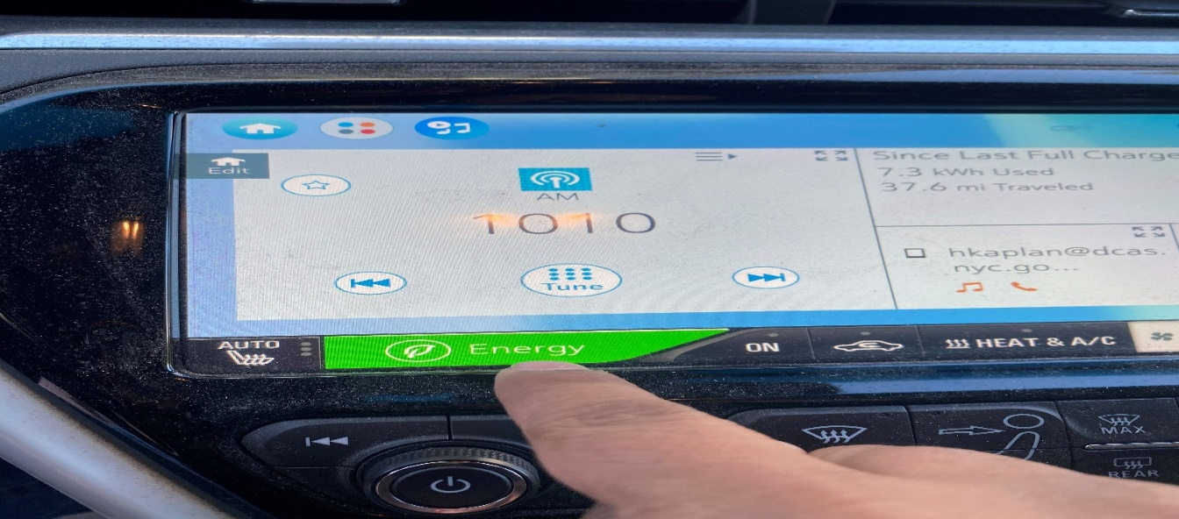

- Once the new page appears press on the on the Charger icon.
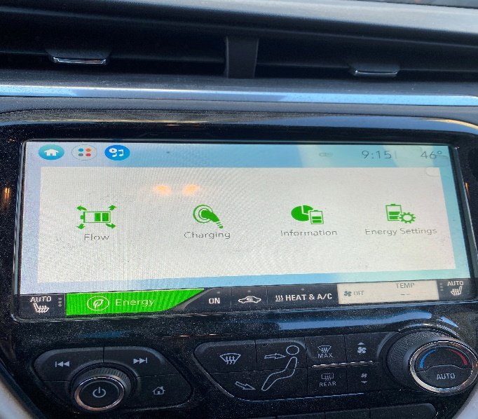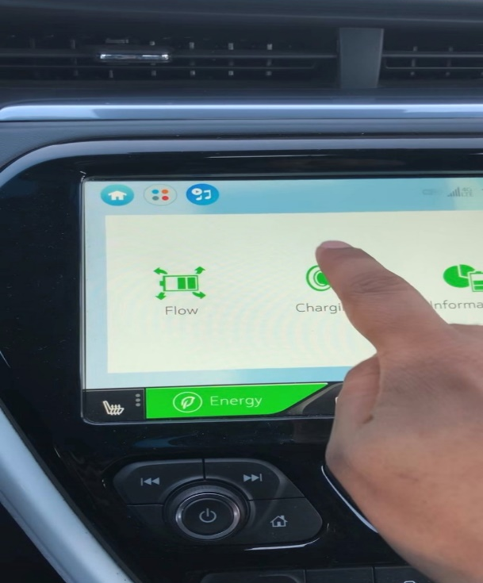

- Once the Charger icon is selected, press on the Target Charge Level tab on the right hand side of the screen. Notice that the battery level is at its max of 100%.
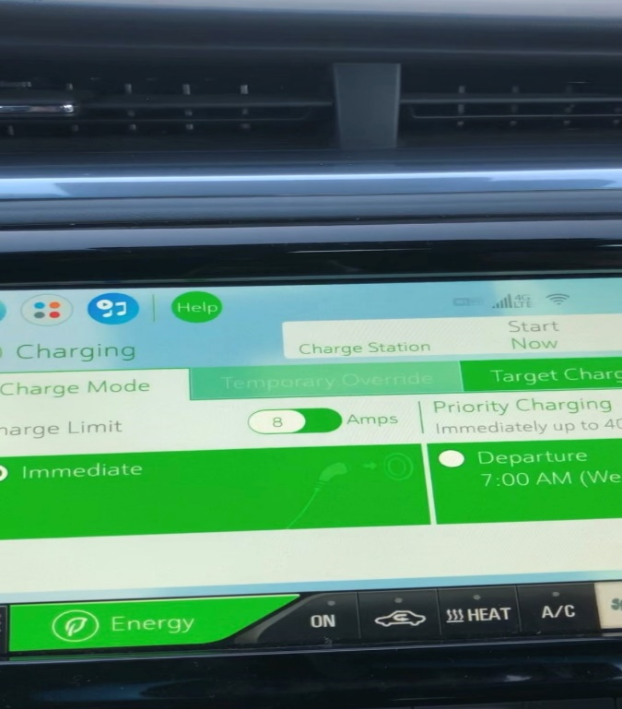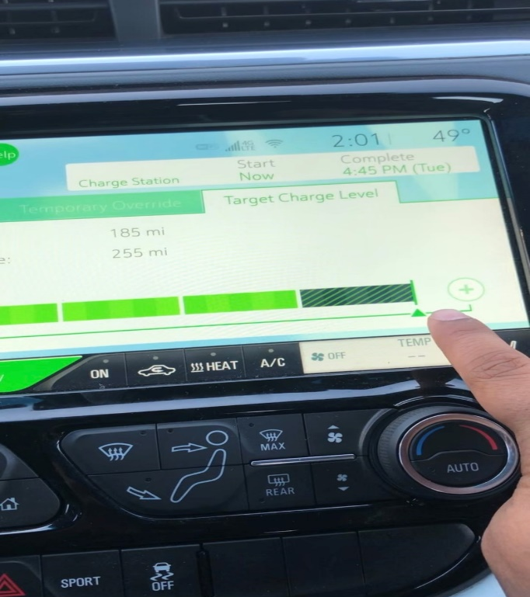

- We have to reduce this level by 10% so that it can equal to 90%. Do this by pressing on the Negative icon 2 times. Once that is completed you will notice that the maximum charge for this vehicle has been decreased.
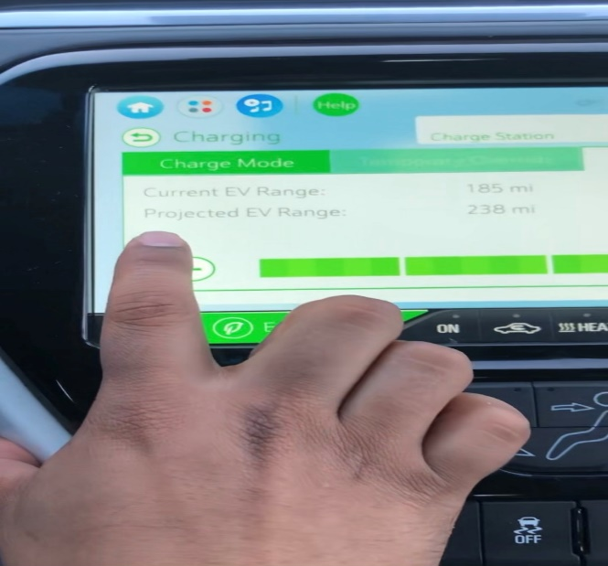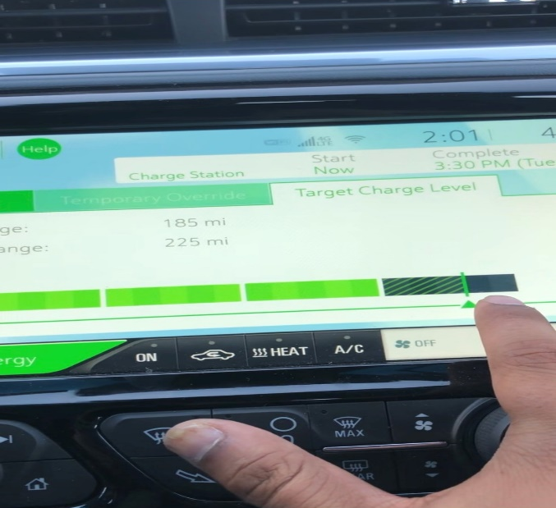
- Head back to the home screen where we originally began, turn off the vehicle, then turn it back on, review the steps and confirm that maximum charge for this vehicle has been decreased.

The interim fix is complete after this last step.

