

2017-2018 Chevrolet Bolt Interim Fix Guide

Due to the recalls affecting 2017-2018 Chevrolet Bolts, DCAS Fleet has created an interim fix that you can perform on your own.
Please note that this interim fix is only for Chevrolet Bolts that are the 2017-2018 model year.
- Everything that you need to know will take place in the infotainment system located in your main console.
- Please make sure that your Bolt is on and NOT plugged in charging.
- On the left-hand side of the screen, press the green energy icon.
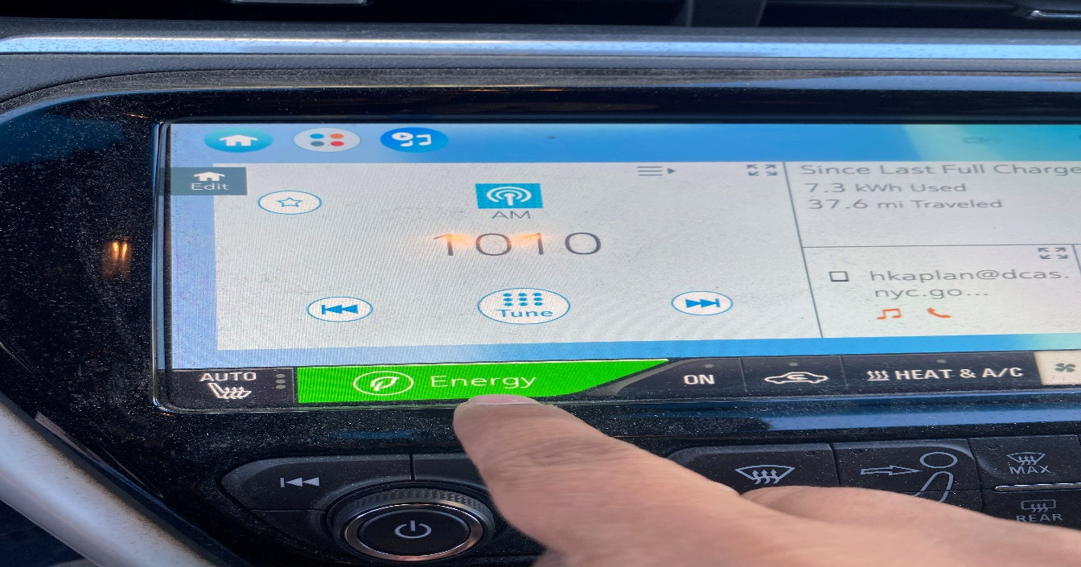

- Once the new page appears press on the on the Energy Settings icon.
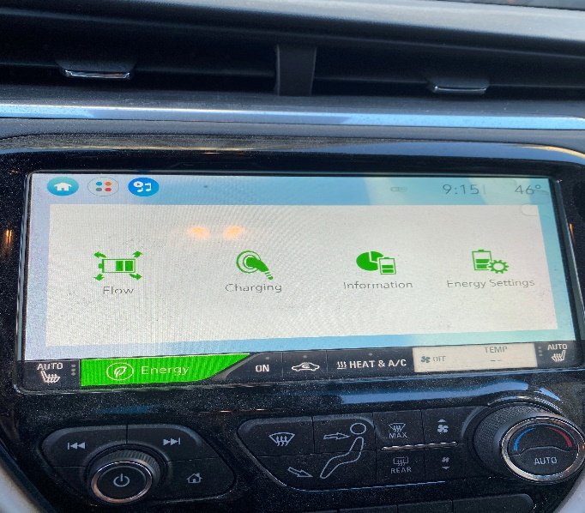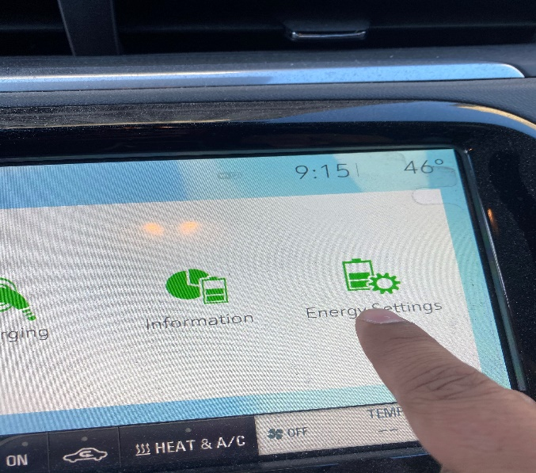

- Then press on Hill Top Reserve and confirm that Hill Top Reserve has been switched to ON.
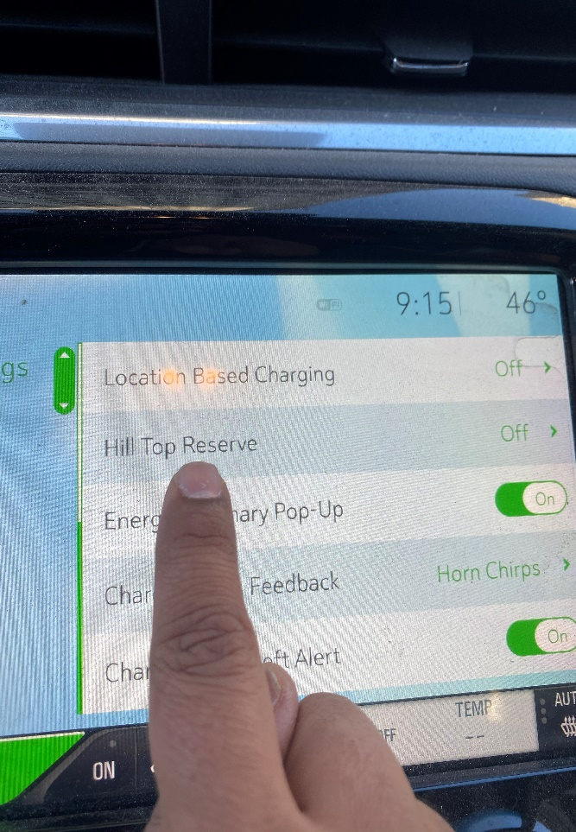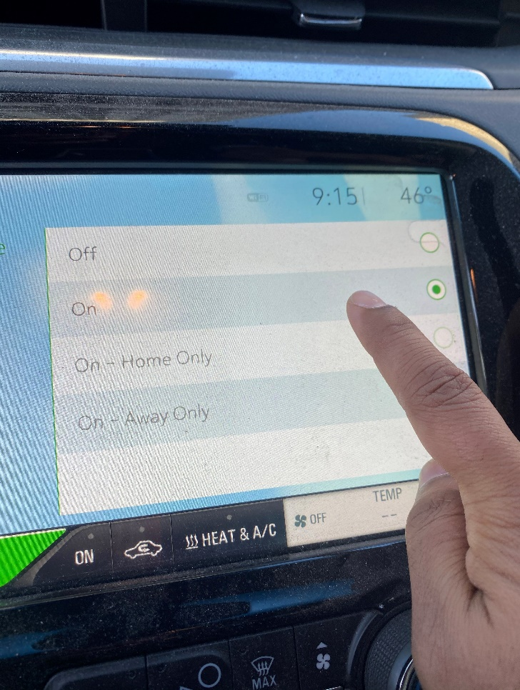

- Head back to the home screen where we originally began, turn off the vehicle, then turn it back on, review the steps and confirm that Hill Top Reserve is in the ON position.

The interim fix is complete after this last step.

